**The Impact of Artificial Intelligence and Machine Learning on the Banking Sector: A Bibliometric Analysis**

A seminar paper submitted to Indian Institute of Foreign Trade (IIFT) in the Partial Fulfilment of requirement for the completion of Coursework for the Degree of Doctor of Philosophy in Management Ph.D. Batch- 2023



Submitted by:

Ravi Kumar Jain

Roll No: 07 (Part Time)

Research Scholar

Indian Institute of Foreign Trade, New Delhi

Email: ravi_phdm23@iift.edu

Under the Guidance of:

Dr. Anju Goswami

Indian Institute of Foreign Trade, New Delhi

Indian Institute of Foreign Trade

Ph.D. Programme

DECLARATION

This is to certify that I, a student of the Ph.D. Programme (2023) at the Indian Institute of Foreign Trade, have submitted the Seminar Paper entitled "The Impact of Artificial Intelligence and Machine Learning on the Banking Sector: A Bibliometric Analysis" as a part of the Course-Work of the Ph.D. Programme. This is an original work. It is neither copied (partially/fully) from any scholastic work, nor is it submitted for any other degree or diploma. I remain fully responsible for any error and plagiarism.

..……………...………………..

Ravi Kumar Jain

(Name / Signature of the student)

CERTIFICATE

This is to inform that Ravi Kumar Jain, student of the Ph.D. Programme (2023), has completed the Seminar Paper on the topic "The Impact of Artificial Intelligence and Machine Learning on the Banking Sector: A Bibliometric Analysis" under my guidance.

..……………...………………..

Prof. (Dr.) Anju Goswami

(Name / Signature of Supervisor)

**Abstract**

Artificial Intelligence (AI) and Machine Learning (ML) are transforming the banking sector by enhancing operational efficiency, customer engagement, risk management, and regulatory compliance. This literature review systematically explores AI/ML applications in banking by analyzing 190 academic articles using bibliometric tools, including Biblioshiny and VOSviewer, and thematic analysis with NVivo. The PRISMA framework was employed to ensure a transparent and reproducible selection of relevant studies. The review identifies four primary domains of AI/ML applications: bank performance management, customer relationship management (CRM), marketing, and risk management. Key applications include fraud detection, credit scoring, predictive analytics, and customer service automation. The findings reveal emerging trends such as the growing adoption of explainable AI (XAI) to improve transparency in decision-making and the increasing use of predictive models to anticipate customer behavior and market fluctuations. However, the study identifies research gaps in ethical AI frameworks, real-time adaptive systems, and the application of unsupervised learning techniques in banking. By addressing these gaps, future research can enhance the responsible implementation of AI/ML technologies in the financial sector. This review provides a comprehensive framework for understanding the current advancements and challenges of AI/ML in banking, offering valuable insights for both academics and practitioners to drive sustainable innovation and growth in financial services.

**Introduction**

Artificial Intelligence (AI) and Machine Learning (ML) are transforming banking, creating innovative solutions for operational efficiency, better customer experiences, and effective risk management. With AI/ML in banking evolving rapidly, a comprehensive understanding of the existing research is crucial for identifying emerging trends, key research, and knowledge gaps. To achieve this, a bibliometric analysis was conducted to systematically review the academic literature and provide actionable insights into the development and adoption of AI/ML technologies in the financial sector.

Bibliometric analysis plays a crucial role in synthesizing vast amounts of academic literature to uncover patterns of collaboration, thematic evolution, and research trajectories. By employing tools such as Biblioshiny and VOSviewer, this study identified key contributors, prominent themes, and influential publications within the domain of AI/ML in banking. This structured approach ensures that the review captures both historical developments and current trends, enabling a robust understanding of the field’s progression.

The study employed the PRISMA (Preferred Reporting Items for Systematic Reviews and Meta-Analyses) framework to ensure a transparent and reproducible process for selecting relevant studies (Malhotra, 2024). Following the PRISMA process, the dataset was further refined through a thematic analysis using NVIVO, a qualitative analysis tool. NVIVO facilitated the categorization and visualization of themes across the selected literature, enabling deeper insights into core areas such as fraud detection, customer relationship management, risk management, and operational efficiency.

The thematic analysis using NVIVO provided a structured approach to identify recurring themes and subthemes in the literature. This analysis highlighted key focus areas within AI/ML research in banking, including predictive analytics, cybersecurity, regulatory compliance, and personalized customer service. By visualizing these themes, NVIVO helped uncover connections between different research areas, offering a holistic view of the field’s current state and future directions.

## Research Questions

This study addresses the following questions:

* How have AI/ML been applied in the banking sector to address key challenges?
* What are the emerging trends in AI/ML research in banking?
* What gaps exist in the current literature on AI/ML applications in banking?
* How can bibliometric and thematic analyses contribute to identifying future research directions in AI/ML for banking?

These questions combine bibliometric and thematic analysis results to offer a broad overview of AI/ML uses in banking. The study seeks to bridge the gap between technological advancements and practical implementations, offering insights that can inform future research and policy development.

By employing a combination of bibliometric and thematic analyses, this study provides a systematic and data-driven understanding of AI/ML applications in banking. Integrating tools such as PRISMA, Biblioshiny, and NVIVO ensures a rigorous approach to literature review, uncovering key insights and research gaps. The findings from this study will contribute to shaping future research agendas, promoting the responsible and effective use of AI/ML technologies in the financial sector.

**Methodology**

This study comprehensively analyzed AI/ML in banking via bibliometrics and thematic analysis. To ensure a diverse and high-quality dataset for analysis, the Scopus database, with its broad coverage of peer-reviewed publications across many fields, was chosen as the primary source.

The review process involved multiple steps to identify key research themes, trends, and gaps in the field. Bibliometric tools such as Biblioshiny and VOSviewer were used to process and visualize bibliographic data, while NVivo was employed for qualitative analysis to identify and categorize recurring themes within literature. These tools, combined with the PRISMA framework, ensured a structured and transparent approach to data collection, analysis, and theme identification.

In the bibliometric phase, Biblioshiny, an R-based application, facilitated the extraction of key insights on citation trends, influential authors, collaborative networks, and keyword co-occurrence. VOSviewer complemented this by generating detailed network maps that highlighted relationships between research topics, authors, and institutions, revealing clusters of related studies and emerging areas of interest.

Following the bibliometric analysis, a thematic review was conducted using NVivo, a qualitative data analysis tool, to further explore the depth and scope of AI/ML research in banking. The use of NVivo allowed for a systematic coding process, enabling the identification of recurring themes across the reviewed articles. We categorized themes like fraud detection, credit scoring, CRM, and operational efficiency to represent established and new AI/ML uses in banking.

The thematic analysis was grounded in a review of the selected articles to understand the contributions made to each research area. By examining the methodologies, findings, and practical implications discussed in the literature, the study identified key advancements, ongoing challenges, and knowledge gaps. NVivo’s structured coding approach ensured that the themes were derived systematically, providing a comprehensive understanding of the evolving research landscape.

The PRISMA framework guided the selection process by ensuring transparency and reproducibility in screening and including relevant studies. This framework documented the inclusion and exclusion criteria, detailing each step from the initial search to the final selection of articles for analysis.

Together, these methodologies provided a holistic approach to examining AI/ML research in banking, integrating both quantitative bibliometric insights and qualitative thematic analysis. The combined use of bibliometric tools and NVivo enabled a nuanced exploration of the evolution of research themes, identifying key contributors, institutions, and application areas while offering valuable insights into future research directions in the field.

**Search Strategy for Bibliometric Analysis on AI and ML in Banking**

The bibliometric analysis began by systematically identifying and retrieving relevant publications from Scopus. The objective was to explore the intersection of AI/ML within the banking sector, focusing on studies that provide insights into technological advancements driving innovation in financial services. A comprehensive keyword strategy was employed to ensure that the dataset encompassed a wide array of pertinent literature while minimizing the inclusion of irrelevant results. The selected keywords encompassed critical terms such as "Banking," "Bank," "Artificial Intelligence," "Machine Learning," and their widely recognized abbreviations, "AI" and "ML," reflecting both foundational and contemporary terminology in the field.

To optimize the accuracy and breadth of the search, logical operators (e.g., AND, OR) were strategically incorporated into the query formulation. These operators allowed for the combination of various keyword sets, ensuring that a diverse range of relevant publications was captured. The search parameters also included subject area filters, focusing on disciplines such as business, economics, computer science, and engineering, which are central to understanding the technological transformations occurring in financial systems. In contrast, fields unrelated to the study’s objectives, such as medical research, were excluded to prevent irrelevant results (e.g., studies on "blood banks"). Additionally, document type filters were applied to restrict the results to journal articles and review papers, which are generally more comprehensive and provide critical reflections on emerging themes in academic research.

The following search query was formulated to ensure a comprehensive and focused dataset:

|  |
| --- |
| “( TITLE ( ( "Banking" OR "Bank" ) AND ( "Machine Learning" OR "Artificial Intelligence" OR "Generative AI" OR "AI" OR "ML" OR "Gen AI" ) ) OR KEY ( "Banking" AND ( "Machine Learning" OR "Artificial Intelligence" ) ) OR SRCTITLE ( Banking OR Bank ) AND TITLE-ABS-KEY ( "Machine Learning" OR "Artificial Intelligence" ) ) AND ( LIMIT-TO ( SRCTYPE , "j" ) ) AND ( LIMIT-TO ( SUBJAREA , "COMP" ) OR LIMIT-TO ( SUBJAREA , "BUSI" ) OR LIMIT-TO ( SUBJAREA , "ENGI" ) OR LIMIT-TO ( SUBJAREA , "ECON" ) OR LIMIT-TO ( SUBJAREA , "SOCI" ) OR LIMIT-TO ( SUBJAREA , "MATH" ) OR LIMIT-TO ( SUBJAREA , "DECI" ) OR LIMIT-TO ( SUBJAREA , "ENVI" ) OR LIMIT-TO ( SUBJAREA , "MATE" ) OR LIMIT-TO ( SUBJAREA , "ENER" ) OR LIMIT-TO ( SUBJAREA , "MULT" ) OR LIMIT-TO ( SUBJAREA , "ARTS" ) ) AND ( LIMIT-TO ( DOCTYPE , "ar" ) OR LIMIT-TO ( DOCTYPE , "re" ) )” |

The structure of the query reflects a rigorous approach to bibliometric research. By leveraging logical operators and applying subject-specific filters, the search was fine-tuned to retrieve scholarly works addressing AI and ML within the banking domain from a multidisciplinary perspective. The inclusion of subject areas such as business and computer science were particularly crucial, given the multifaceted nature of technological innovation in financial services. Furthermore, the restriction to peer-reviewed journal articles and review papers enhanced the reliability and academic rigor of the dataset. This meticulous query design ensured that the final dataset would support a robust bibliometric analysis, providing valuable insights into the scholarly discourse surrounding AI and ML applications in banking.

The refined search strategy and query formulation serve as a solid foundation for the subsequent bibliometric analysis, enabling the identification of influential works, emerging research themes, and knowledge gaps within this rapidly evolving domain.

**PRISMA Flow Diagram for Study Selection**

The PRISMA flow diagram offers a clear, transparent representation of the systematic study selection process for this literature review on AI and ML in banking. From an initial pool of 1,441 records, automated screening excluded 880 irrelevant or duplicate entries. After detailed screening, 243 records were unavailable, leaving 312 reports for eligibility assessment. Following evaluation based on topic relevance and Q1 quartile inclusion, 198 high-quality studies were selected for the final review. Key studies contributing to this review include open-access papers such as those by Nguyen et al. (2021), exploring AI-driven risk management in banking, and Kumar et al. (2022), discussing ML applications in fraud detection.

This systematic approach ensures that the included studies are both relevant and credible, enhancing the reliability and focus of the review. By prioritizing high-impact, open-access literature, the process lays a strong foundation for understanding key themes, trends, and gaps in AI and ML research in banking.

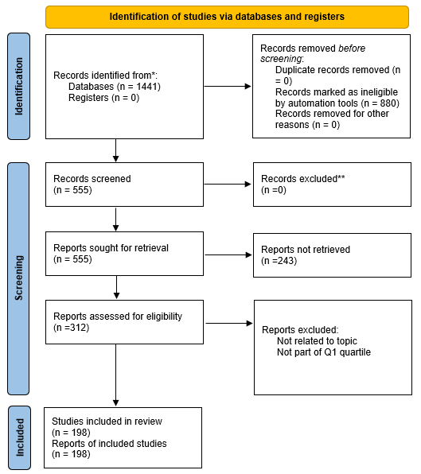

**Bibliometric Analysis of AI and ML in Banking**

**Findings from Biblioshiny Analysis**

The query results obtained from Scopus were further refined and analyzed using Biblioshiny, a user-friendly web-based interface of the R package Bibliometrix. After exporting relevant research articles from Scopus in CSV format, the data was uploaded to Biblioshiny to perform an in-depth bibliometric analysis. Biblioshiny facilitated the extraction of key insights by generating various metrics, such as author contributions, citation trends, keyword co-occurrence, and thematic evolution. This tool allowed for visual representation of bibliographic networks, such as collaboration maps and thematic clusters, providing a clearer understanding of research patterns and trends. By applying Biblioshiny, the data from Scopus was transformed into actionable insights, which helped in identifying influential works, emerging themes, and research gaps within the chosen field of study.

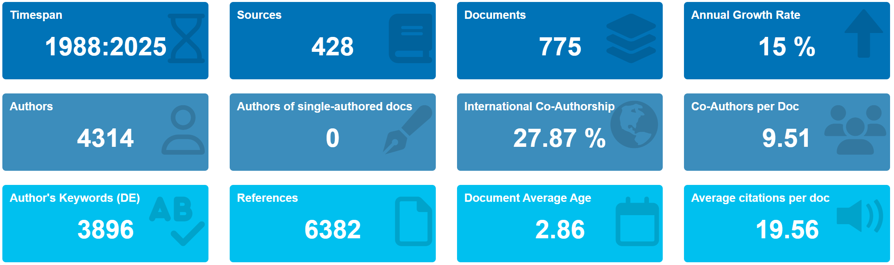

Figure 1: Main Findings from Bibliometric Analysis Using Biblioshiny

The bibliometric analysis covers the timespan from 1988 to 2024, identifying 555 documents sourced from 333 journals. The study reveals a 14.6% annual growth rate, resulting from the contributions of 1,620 authors, averaging 3.14 co-authors per document. Only 61 single-authored works were identified, while the international co-authorship rate stands at 26.49%. The study highlights 1,633 unique keywords and references a total of 28,336 sources, with an average of 17.71 citations per document. The average age of documents is 2.86 years, reflecting the relatively recent nature of this research. The findings reveal the highly collaborative and dynamic nature of AI/ML research in banking. Strong international partnerships reflect efforts to address global challenges, while the diversity of topics explored, as suggested by the large number of unique keywords, points to the wide-ranging focus of this research. The recency of the documents highlights the field’s alignment with rapid technological advancements, emphasizing the continuous exploration of new opportunities and challenges in the sector.

**Annual Scientific Production**

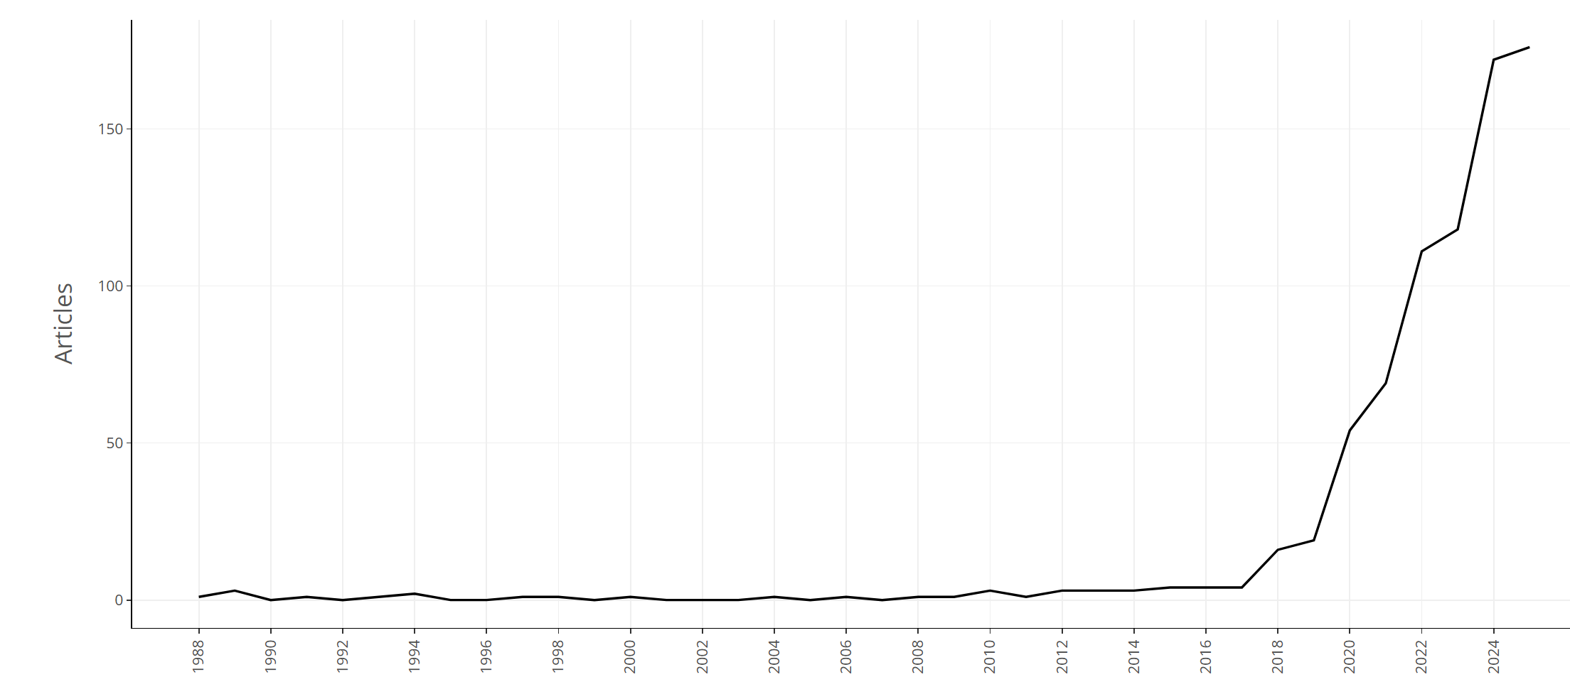

Figure 2: Annual Scientific Production

The annual scientific output in AI/ML banking research from 1988 to 2024 is depicted in Figure 2. The data reveals a prolonged period of low and relatively stable research activity from 1988 until around 2016. However, from 2017 onward, there is a clear and dramatic increase in the number of publications, indicating significant growth in research output in this field.

This trend demonstrates a marked shift in research activity post-2017, reflecting the growing attention to AI/ML in banking. The sharp rise in publications suggests a rapidly expanding interest in exploring and applying these technologies within the sector.

**Most Relevant Sources**

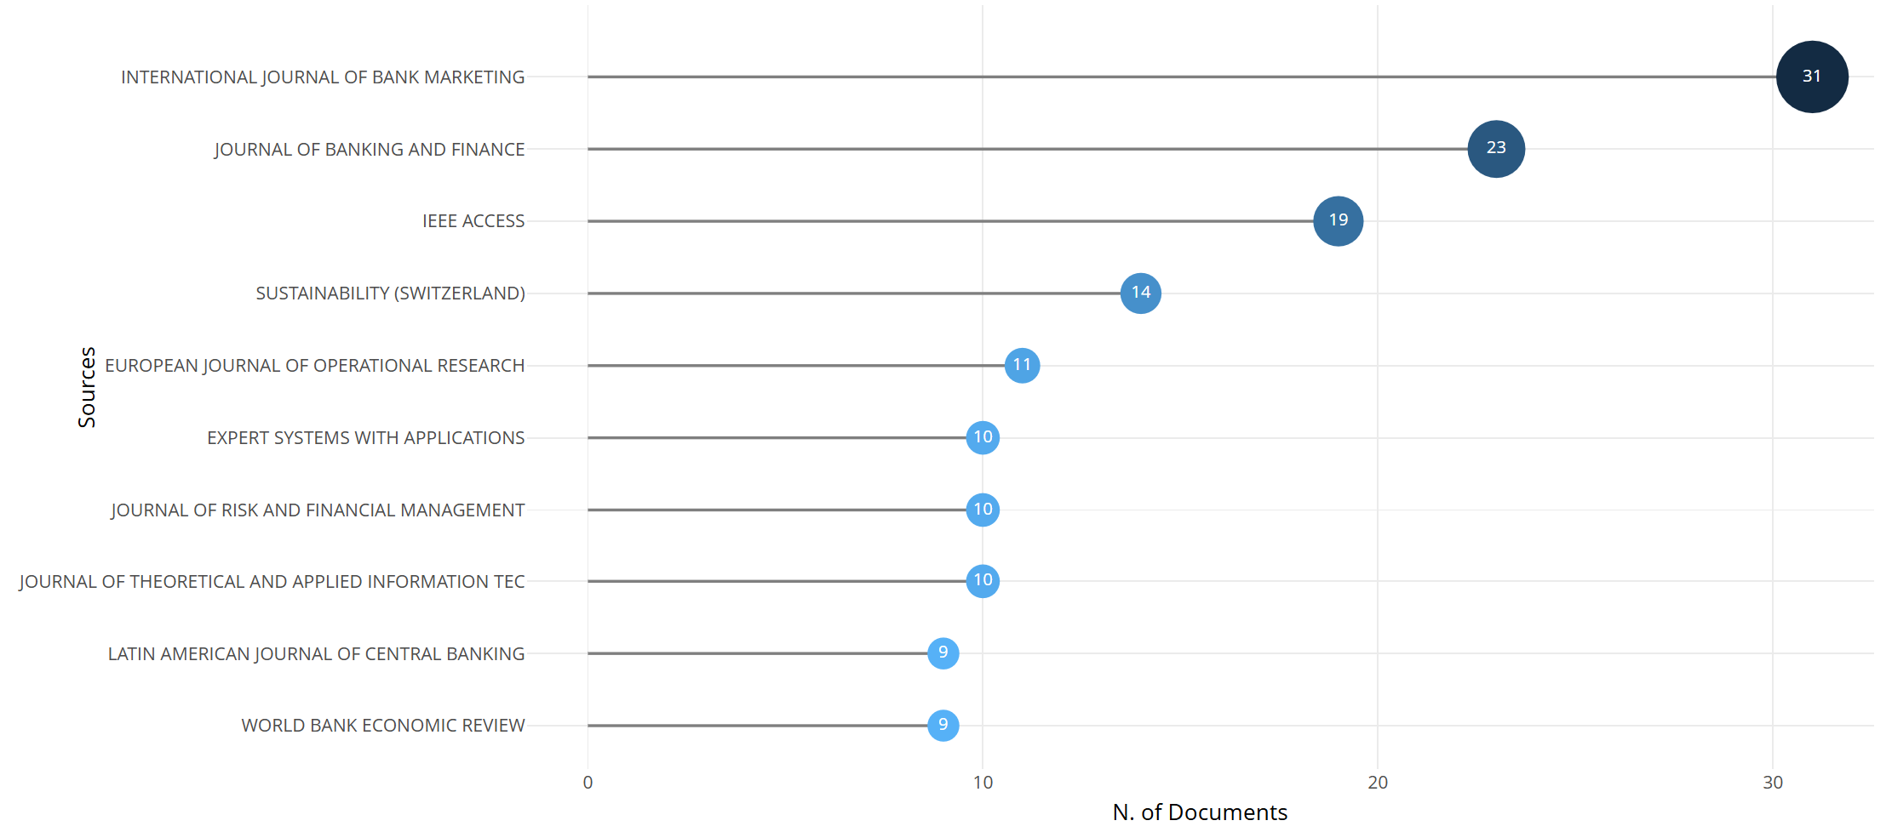

Figure 3: Most Relevant Sources

Figure 3 showcases the most pertinent journals that publish research focusing on AI and ML applications in the banking sector. The International Journal of Bank Marketing leads with 24 articles, followed by the Journal of Banking and Finance (19 articles) and IEEE Access (13 articles). Other key contributors include Sustainability (Switzerland) (12 articles), the European Journal of Operational Research (9 articles), and Expert Systems with Applications (9 articles). The distribution of publications across these journals demonstrates the interdisciplinary nature of AI/ML research, spanning topics such as marketing, financial systems, and operational efficiency.

**Most Relevant Authors**

Figure 4: Most Relevant Authors

Figure 4 identifies the leading authors contributing to AI and ML research in the banking sector. Notable contributors, including Castelli Mauro, Cavus Nadire, Chhabra Roy Neha, Piotrowski Dariusz, and Rajesh Anupama, each have four publications, while authors like Guerra Pedro, Han Qian, and Lee Jung-Chieh have authored three articles.

The presence of diverse authors from fields such as computer science, finance, and engineering underscore the interdisciplinary nature of AI/ML research in banking. These authors' work spans critical areas like fraud detection, risk management, customer personalization, and operational efficiency, reflecting the wide-ranging applications of these technologies.

These authors’ contributions highlight collaboration and innovation in banking. Their research provides a firm foundation for further studies, fostering the continuous evolution of AI/ML applications in finance.

**Authors’ Production Over Time**

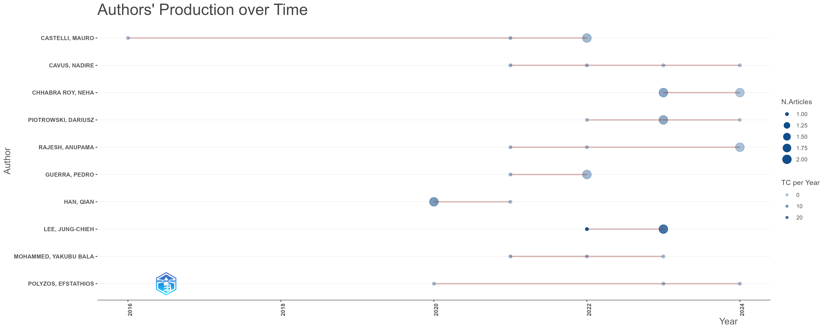

Figure 5: Authors’ Production Over Time

Figure 5 highlights the production timeline of key authors in AI and ML research for banking, illustrating their sustained contributions over time. Authors such as Castelli Mauro and Cavus Nadire have consistently published in recent years, reflecting ongoing engagement with the evolving challenges and opportunities in this field.

The timeline shows increased activity after 2017, aligning with the broader surge in research interest. This rise can be attributed to advancements in AI/ML technologies and their growing adoption in the banking sector. The data also reveal that contributions are distributed across various years, indicating that the field attracts both sustained efforts from established researchers and periodic input from new contributors.

These production trends provide valuable insights into the persistence and focus of influential researchers, showcasing their role in shaping the trajectory of AI/ML research in banking. Understanding these patterns is crucial for identifying leaders in the field and aligning future research directions with emerging trends.

**Corresponding Author’s Countries**

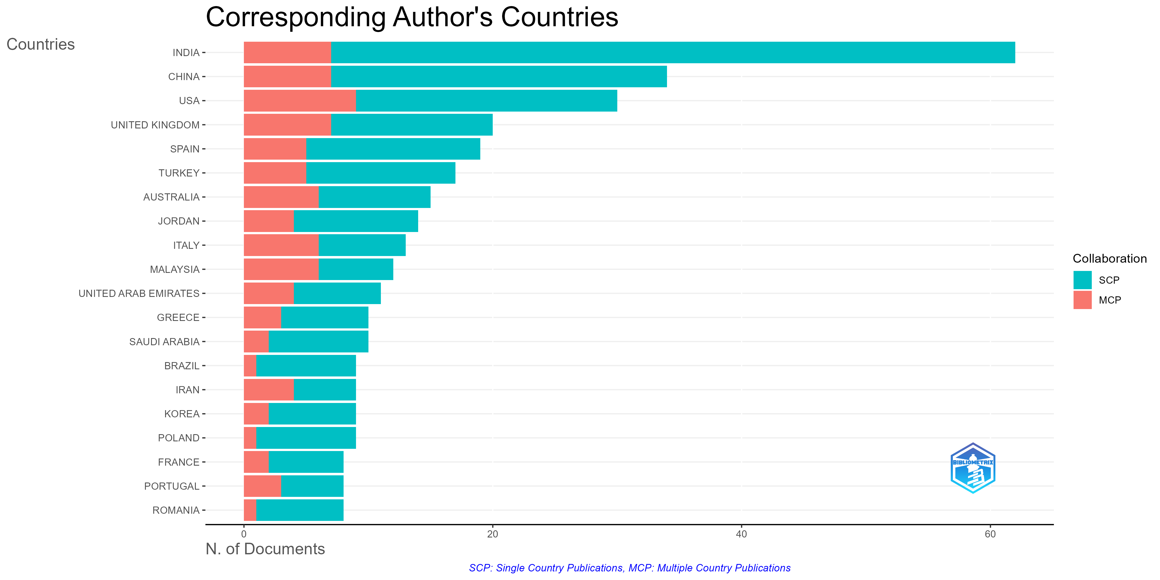

Figure 6: Corresponding Author’s Countries

Figure 6 presents the geographic distribution of corresponding authors in AI and ML banking research. The highest number of contributions originates from India, followed by those from China, the USA, and the UK. These nations dominate the research landscape because of their advanced research infrastructure, significant banking industries, and strategic focus on AI/ML innovations.

The analysis reveals a high number of single-country publications (SCP) from India and China, showing strong domestic research efforts. In contrast, the USA and the UK exhibit a balanced mix of SCP and multiple-country publications (MCP), reflecting their active participation in both independent initiatives and international collaborations. MCPs emphasize the global nature of this field, facilitating cross-border exchange of ideas and expertise.

This distribution underscores the widespread interest in AI/ML applications in banking across both developed and emerging economies. It highlights how countries with diverse economic and technological contexts contribute to advancing AI/ML-driven innovations in the financial sector.

**Country Scientific Production**

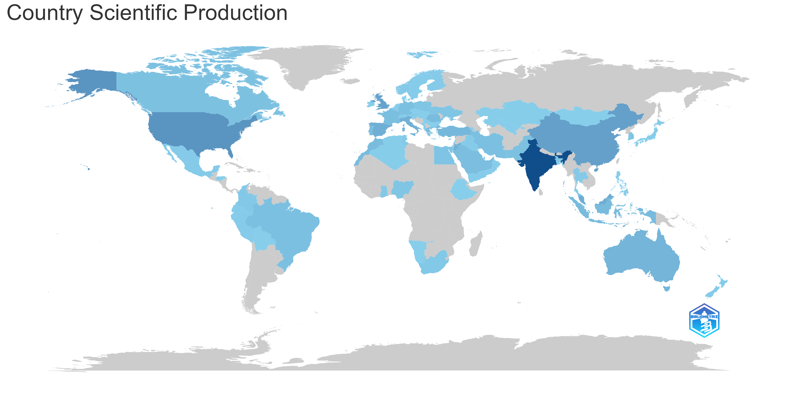

Figure 7: Country Scientific Production

Figure 7 provides a pictorial representation of the contribution of different countries to research in AI and ML in the banking sector. The map highlights the significant global interest, with countries like India, China, the USA, and the United Kingdom making notable contributions.

**Country Production Over Time**

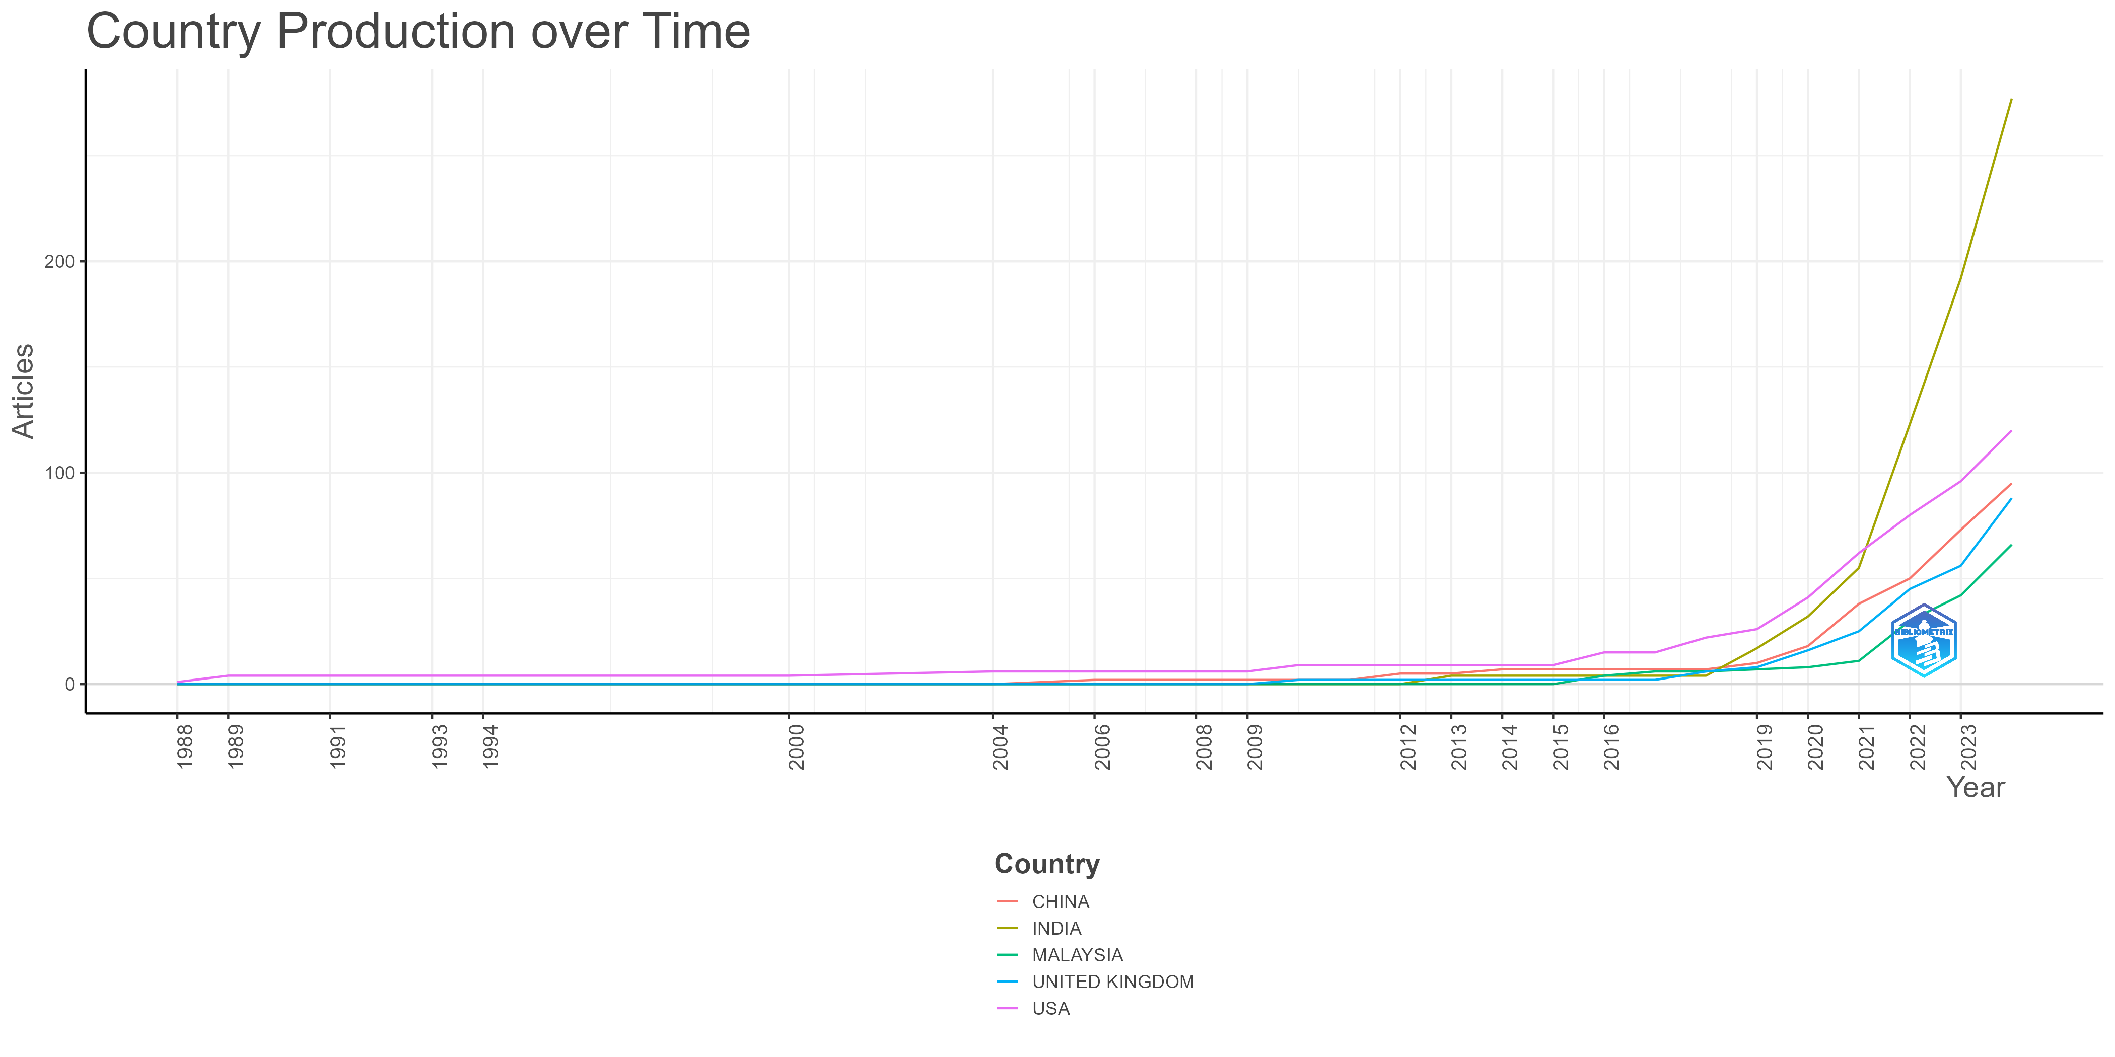

Figure 8: Country Production Over Time

Figure 8 shows the production of research articles over time by country, indicating a significant increase in contributions from countries such as China, India, Malaysia, the United Kingdom, and the USA after 2016. The upward trend demonstrates the growing global interest in AI and ML applications in banking, with notable contributions from emerging and developed economies alike. This trend aligns with the increasing integration of advanced technologies into banking operations, which necessitates continued research to address both opportunities and challenges in the sector.

**Most Relevant Keywords and Visual Representations**

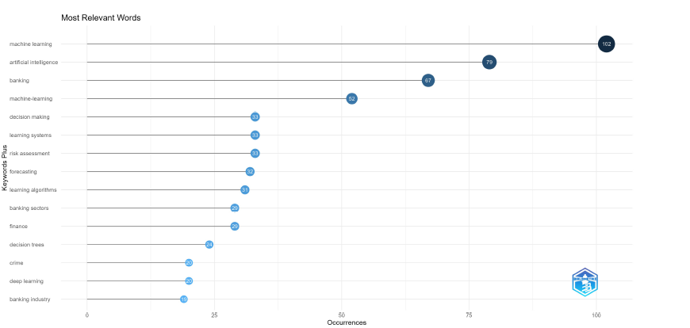

Figure 9: Most Relevant Words

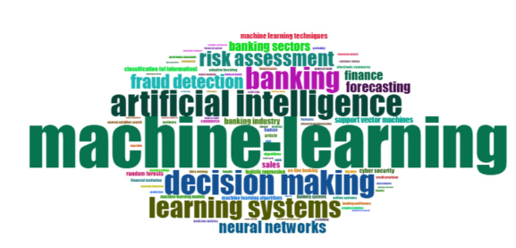

Figure 10: Word Cloud

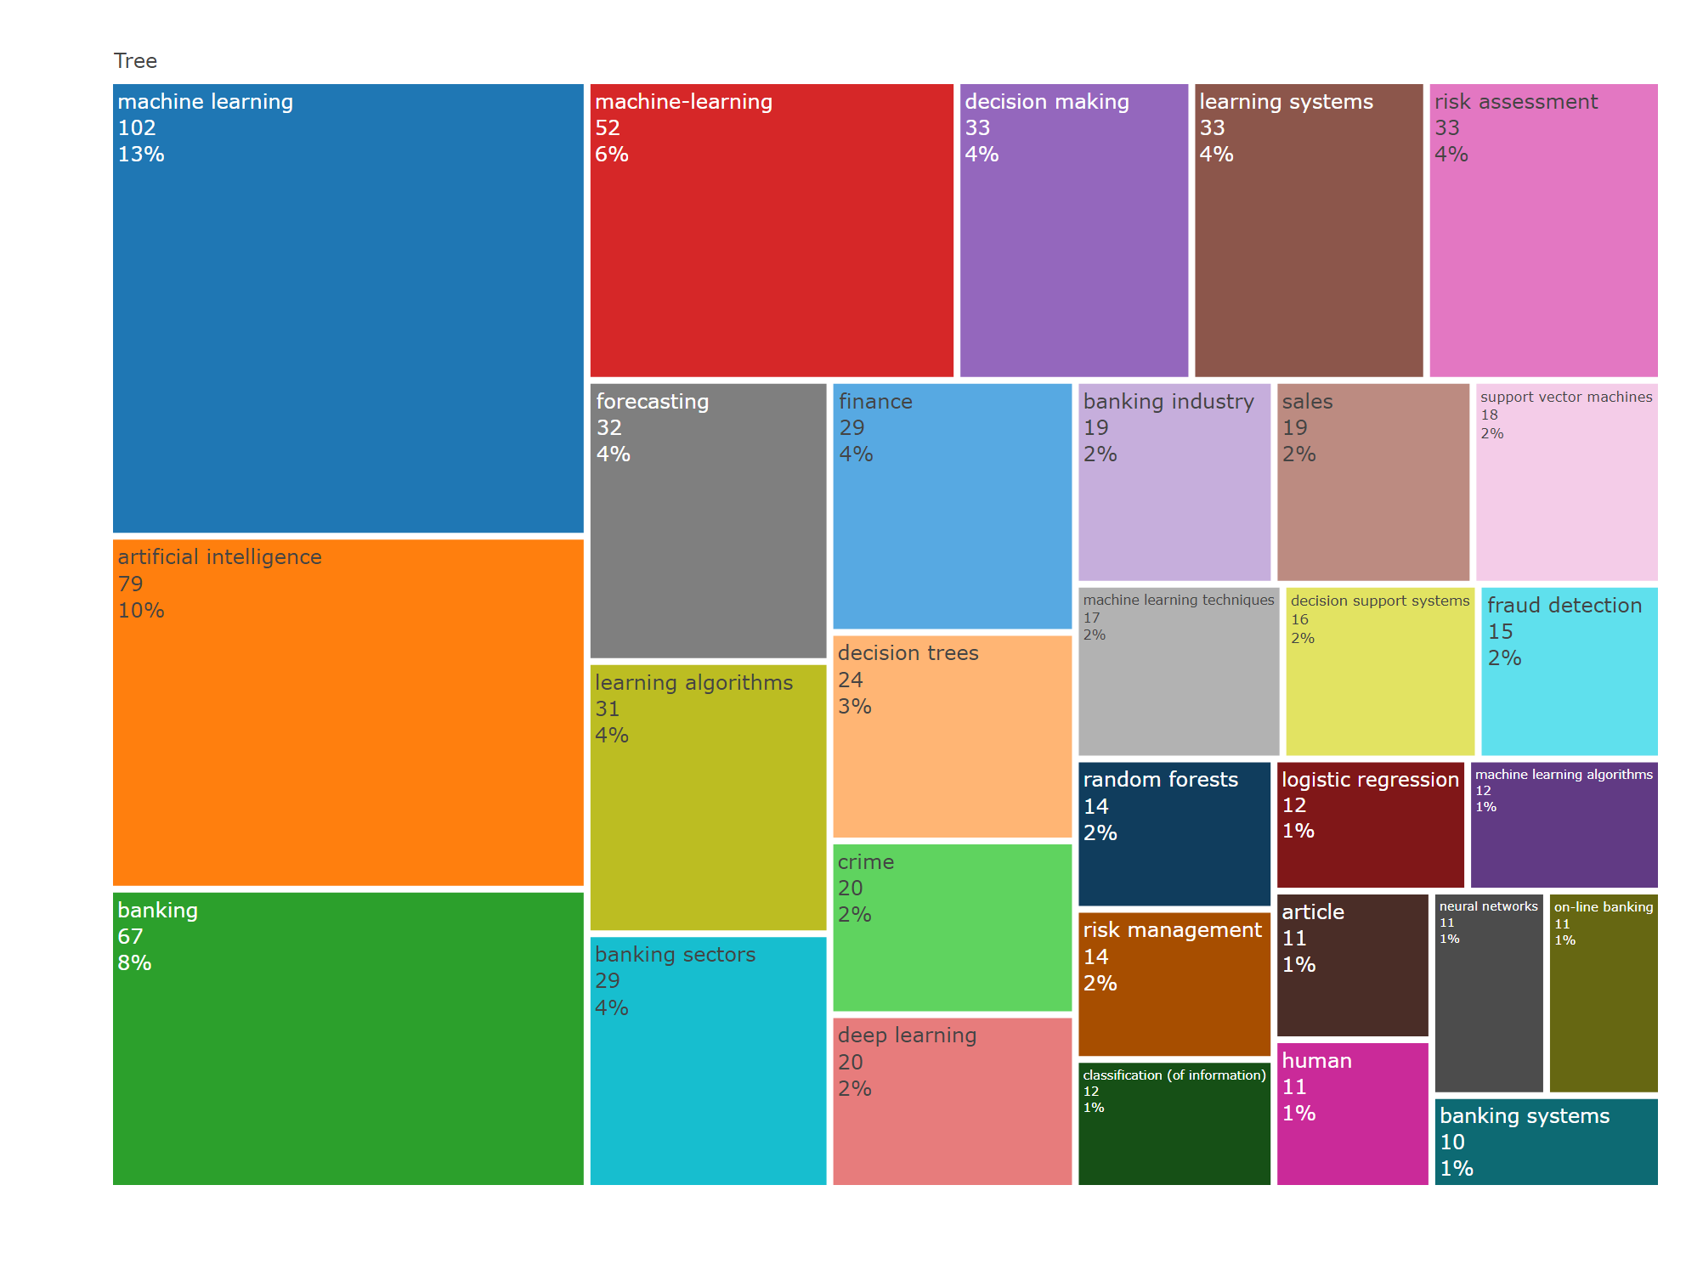

Figure 11: Word Treemap

Figures 9, 10, and 11 highlight key AI/ML research themes in the banking sector, with prominent keywords including "decision making," "learning systems," "risk assessment," and "fraud detection." These themes reflect the focus on enhancing operational efficiency and mitigating risks through AI/ML solutions.

Figure 9's bar chart shows the frequency of keywords, led by "decision making" with 73 occurrences. Figure 10’s word cloud visually reinforces this dominance, with larger font sizes representing higher relevance. The treemap in Figure 11 provides a comparative view, emphasizing "decision making" and "learning systems" as primary topics, while also identifying secondary areas like "support vector machines," "cybersecurity," and "random forests."

These visualizations collectively highlight core research areas and the diverse applications of AI/ML in banking, particularly in improving decision-making, risk management, fraud detection, and cybersecurity.

**Co-Authorship Network by Country**

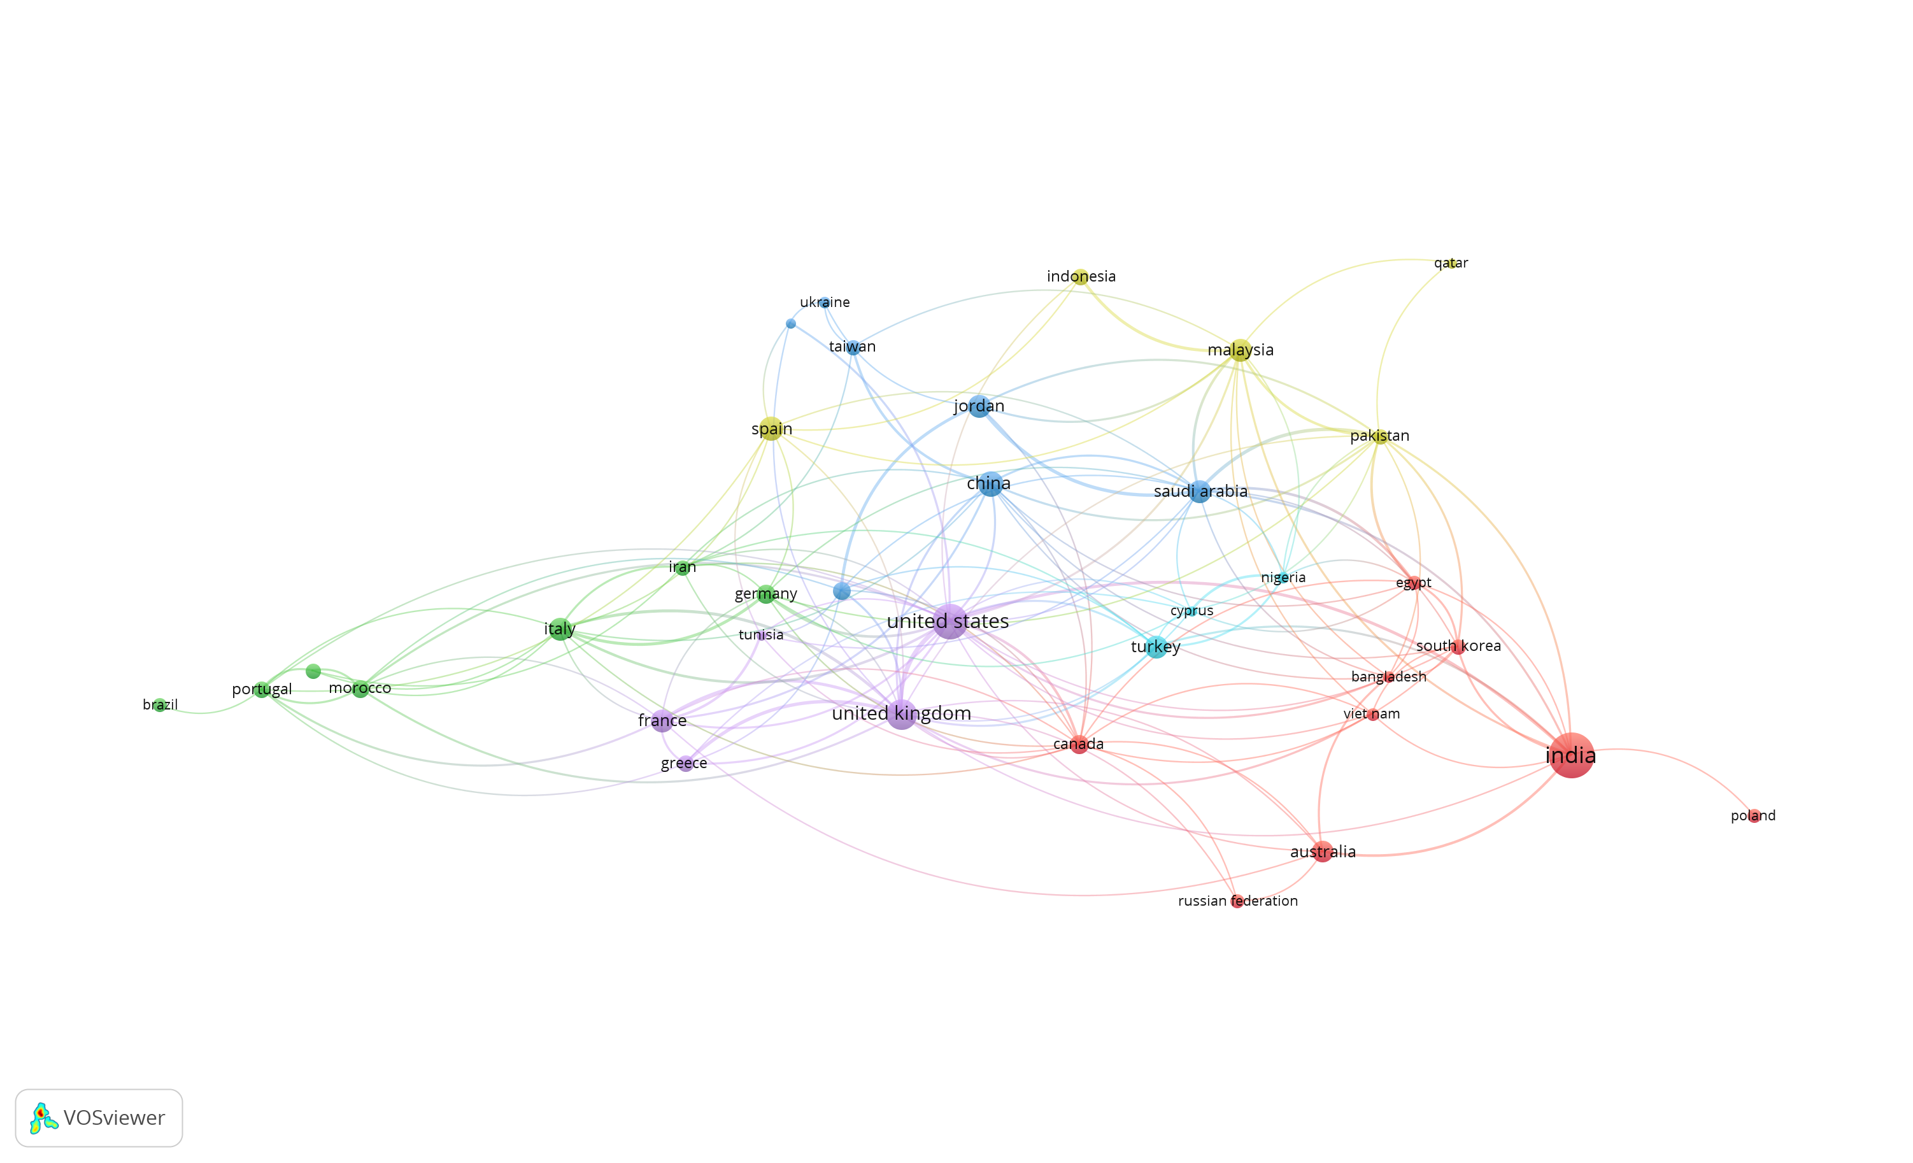

Figure 12: Co-Authorship Network by Country

The co-authorship network visualized using VOSviewer illustrates global collaboration patterns in AI and ML research for banking. India emerges as a central hub with extensive connections across continents, reflecting its active engagement in international research efforts. Similarly, the United States and the United Kingdom serve as key nodes, fostering collaboration with both developed and emerging economies.

The strength of co-authorship links, represented by link thickness, highlights significant research partnerships, such as those between India and the United States. These collaborations underscore the diverse and inclusive nature of research in this field, drawing on expertise from different regions to tackle global challenges like fraud detection, risk management, and customer service optimization.

This co-authorship analysis provides a clear understanding of the global research landscape, identifying leading countries and highlighting opportunities to strengthen international ties further. Such collaborations are crucial for fostering innovation and developing solutions that benefit the banking sector worldwide.

**Co-Occurrence Network of Keywords in AI and ML Research in Banking**

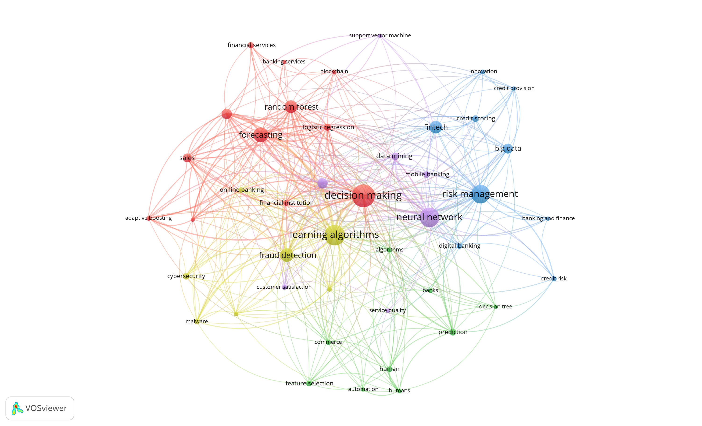

Figure 13: Co-Occurrence Network of Keywords

The co-occurrence network generated using VOSviewer illustrates the relationships between frequently used keywords in AI/ML research within the banking sector. Central themes such as "decision-making," "risk management," "learning algorithms," "neural networks," and "fraud detection" dominate the research landscape, as reflected by the size and connectivity of their nodes.

The clusters, represented by different colors, group related keywords, revealing thematic overlaps and key areas of research focus. For example, the grouping of "decision-making" and "forecasting" emphasizes their importance in predictive analytics, while the connection between "risk management" and "neural networks" highlights advancements in credit scoring and risk modeling. Emerging links, such as the association between "cybersecurity" and "fraud detection," indicate growing attention to security challenges within the banking industry.

This analysis provides valuable insights into the scope and interconnections of AI/ML applications in banking, identifying both well-established topics and areas with potential for further exploration. It offers a roadmap for researchers and practitioners aiming to drive innovation in financial services.

**Bibliographic Coupling Analysis**

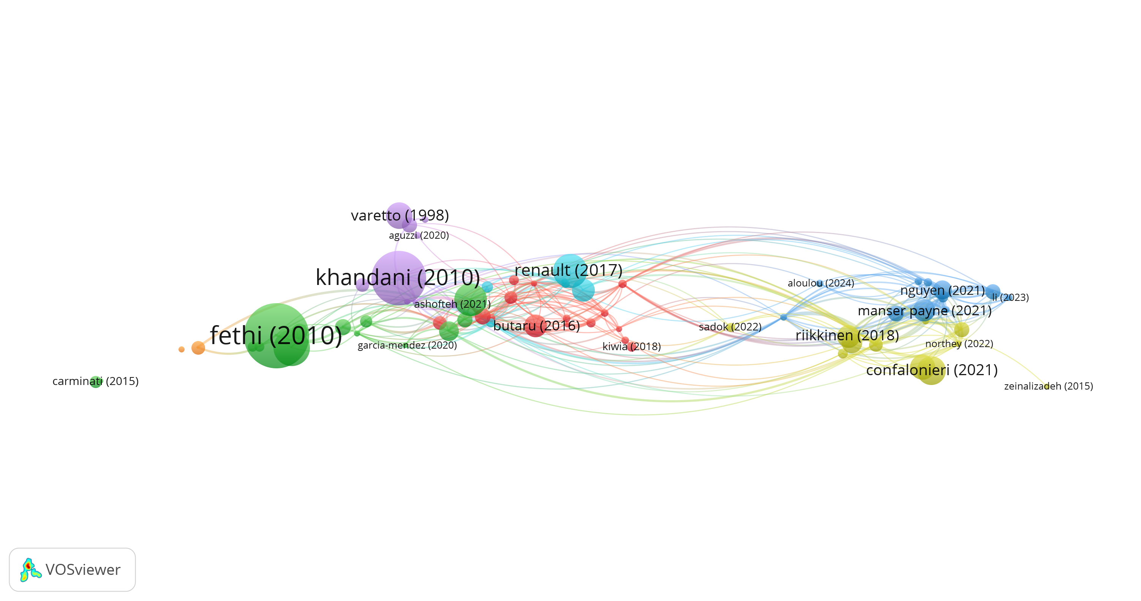

Figure 14: Bibliographic Coupling Analysis

Figure 14 depicts the bibliographic coupling network illustrating interrelationships among pivotal publications in the fields of artificial intelligence and machine learning within the banking industry. Nodes represent individual studies, with their size corresponding to citation frequency, and links indicate shared references between them. Foundational works like "Khandani (2010)" and "Fethi (2010)" are central in the network, forming prominent clusters that reflect their significant influence on the development of AI/ML applications in banking.

The network clusters reveal thematic cohesion among groups of papers, showcasing areas such as credit risk modeling, fraud detection, and operational efficiency as core research themes. This highlights key publications’ impact and research evolution via shared references.

By mapping the connections between influential studies, this analysis provides a valuable resource for identifying foundational research and emerging trends. It also helps scholars pinpoint opportunities for collaboration and gaps in the literature, guiding the direction of future work in AI and ML for banking.

**Co-Citation Analysis of Journals**

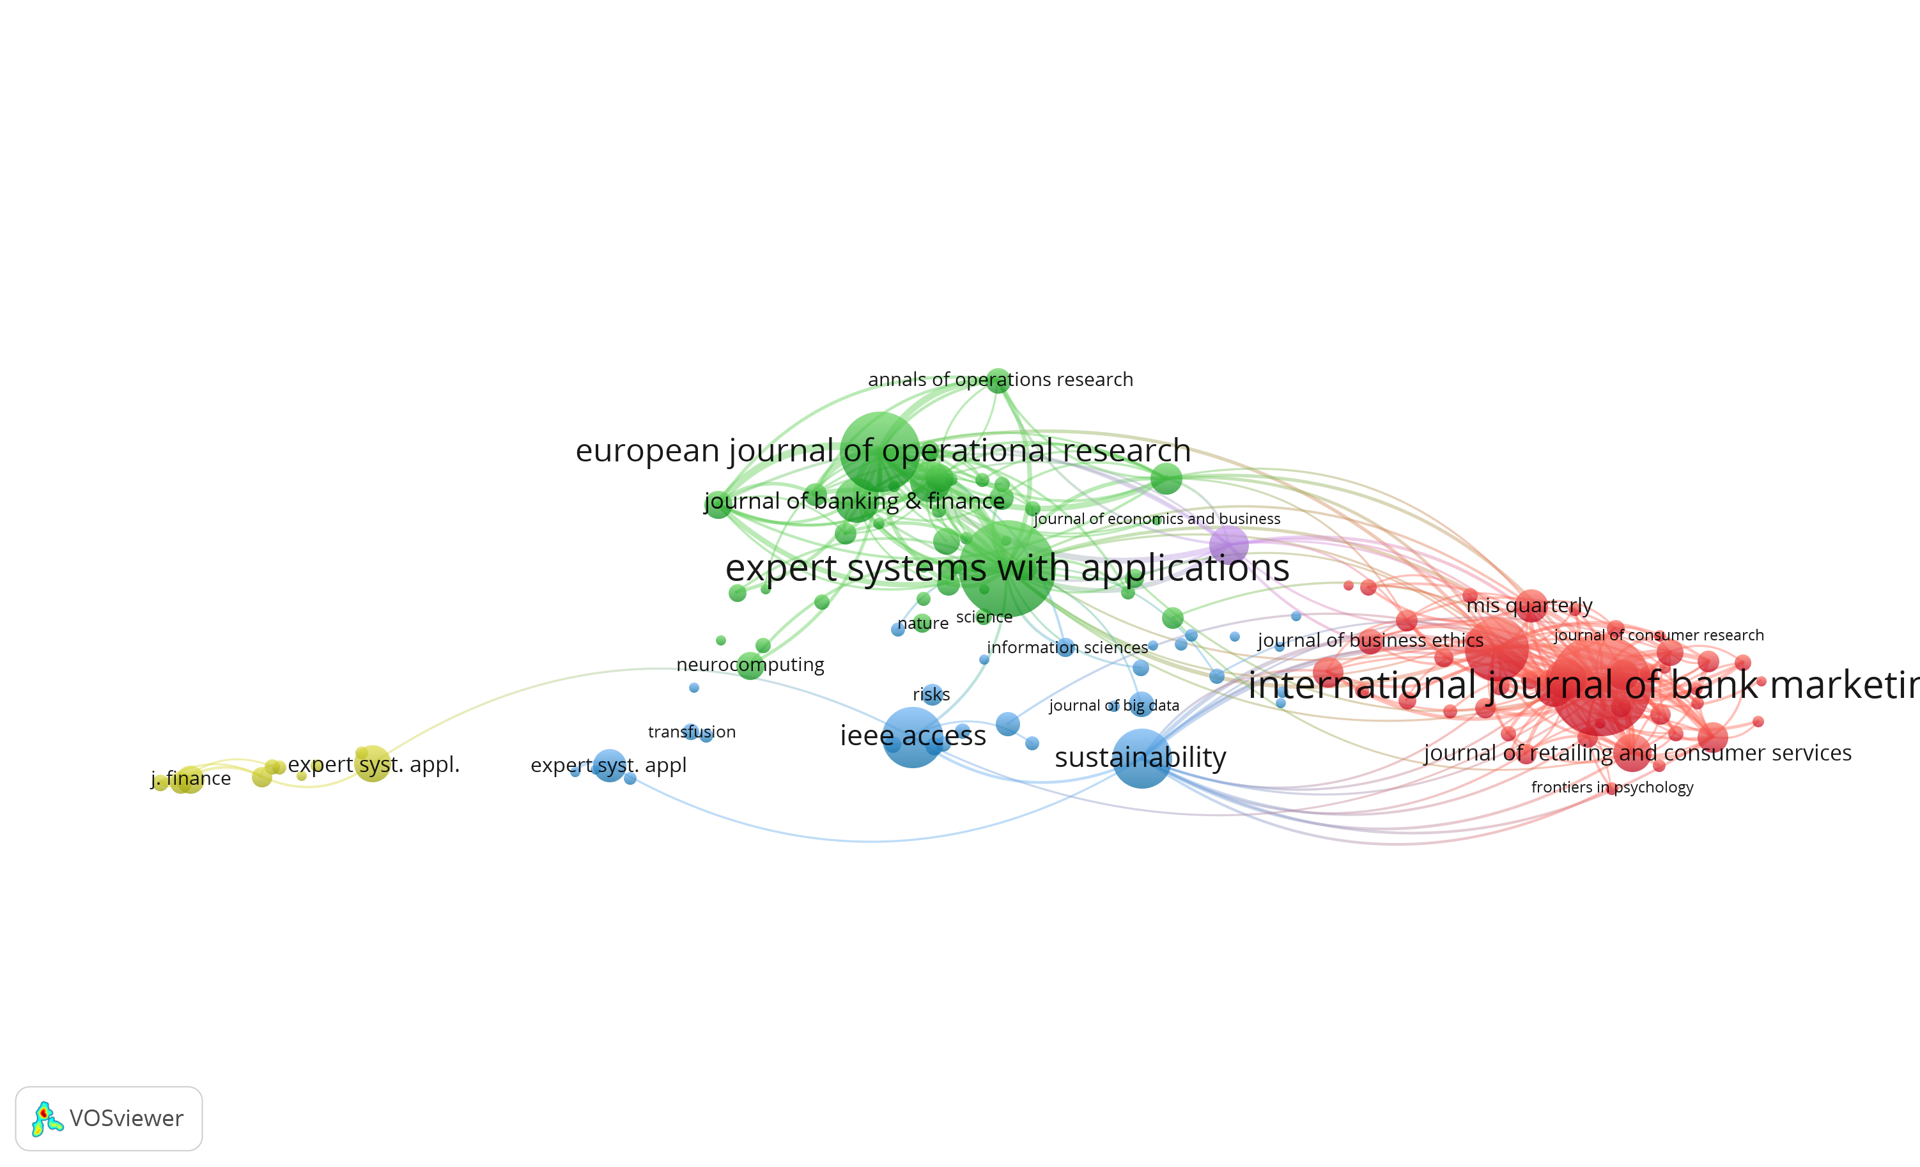

Figure 15: Co-Citation Analysis of Journals

The co-citation network highlights the most influential journals in AI and ML research within the banking sector, with key sources like the International Journal of Bank Marketing, Expert Systems with Applications, and European Journal of Operational Research positioned centrally. Their high co-citation frequency underscores their foundational role in areas such as decision-making, customer behavior, and risk management.

Connections with journals like IEEE Access and Sustainability reveal a growing focus on the ethical and sustainability implications of advanced technologies in financial services. These links emphasize the interplay between technical innovations and broader societal and market considerations.

This analysis provides valuable insights into the intellectual structure of the field, identifying core knowledge bases and interdisciplinary linkages that shape AI/ML applications in banking. It aids researchers in navigating the literature and identifying influential works that drive advancements in this evolving domain.

**Thematic Analysis of AI and ML Applications in Banking**

In our literature review, we aim to categorize the various areas in which AI/ML technologies can support the banking industry. The goal is to provide a comprehensive framework that reflects both traditional banking priorities and emerging areas where AI/ML can offer significant enhancements.

To ensure a structured and rigorous thematic review, we leveraged NVivo, a qualitative data analysis tool, which is particularly useful for organizing and analyzing large volumes of literature. The structured process of thematic analysis through NVivo allows for a systematic identification of key themes across diverse sources. O'Neill, Booth, and Lamb (2018) introduced the N7+1 Pedagogy, an eight-step framework for conducting literature reviews using NVivo. Their methodology outlines a clear path from project setup to coding and visualizing literature, ensuring transparency and rigor in thematic development.

While O'Neill et al.'s framework involves tools such as NCapture and EndNote for literature management, we adapted the process to incorporate Scopus for literature retrieval and Zotero for reference management. This adaptation ensures accessibility and compatibility with the tools commonly used in academic research. Steps such as literature coding and visualization were conducted in NVivo, with additional bibliometric analyses performed using Biblioshiny and VOSviewer to verify and refine the categories identified through thematic analysis.

Our thematic analysis is guided by the framework proposed by Hassani et al. (2020), who identified three primary domains for deep learning implementations in banking: marketing, customer relationship management (CRM), and risk management. These domains provide a foundational structure for categorizing AI/ML applications in banking. However, we expanded this framework to include additional categories relevant to contemporary banking needs into four primary domains: Bank Performance Management, Customer Relationship Management (CRM), Marketing, and Risk Management. These categories provide a comprehensive framework that captures both traditional banking operations and emerging areas where AI/ML technologies are driving innovation. Using NVivo for qualitative analysis, the study systematically identified recurring themes across the literature, which were further validated through bibliometric insights using Biblioshiny and VOSviewer.

1. Bank Performance Management

In the crucial area of bank performance management, AI and ML are modernizing traditional practices through better decisions, optimized resources, and increased efficiency. AI-driven predictive analytics tools help banks forecast market trends, customer behavior, and financial risks, enabling proactive decision-making and long-term strategic planning.

In addition to forecasting, banks use AI tools for portfolio and wealth management, providing personalized investment strategies tailored to customer profiles and risk tolerance levels. These models analyze vast amounts of financial data to recommend optimal investment solutions, improving customer satisfaction and loyalty. Furthermore, by automating routine tasks such as performance reporting and compliance tracking, AI contributes to improving overall efficiency and profitability in banking operations.

1. Customer Relationship Management (CRM)

The Customer Relationship Management (CRM) domain focuses on improving customer engagement and personalization through AI-driven solutions. One key area within this domain is customer churn prediction and retention, where predictive models analyze customer behavior to identify those at risk of leaving and implement targeted retention strategies. By understanding the reasons behind customer churn, banks can develop more effective engagement plans to improve loyalty.

Another major application is customer service automation and personalization. AI-powered chatbots and virtual assistants are widely used to handle routine customer inquiries, offering personalized financial advice, and improving overall service delivery. Implementing these technologies results in faster response times, improved customer satisfaction, and the reallocation of human resources toward more intricate tasks.

Portfolio and wealth management is another important subcategory, where banks use AI to offer tailored investment advice and manage customer portfolios. These tools help customers make informed financial decisions based on real-time market data and individual risk preferences, enhancing their overall banking experience.

1. Marketing

The Marketing domain focuses on leveraging AI and ML technologies to enhance customer engagement, optimize marketing strategies, and drive revenue growth. Cross-selling and customer segmentation are two key areas where AI tools analyze customer data to identify opportunities for offering additional products and services that align with customers' needs. This targeted approach improves marketing efficiency and boosts customer satisfaction.

Technology adoption and technology critique are also important subcategories, reflecting the growing reliance on AI-driven solutions to improve marketing operations and customer outreach. Banks are increasingly adopting AI tools to automate marketing processes, improve customer insights, and enhance brand loyalty through personalized offers and campaigns.

In addition, predictive analytics and market forecasting models are widely used to anticipate customer behavior, market trends, and emerging business opportunities. These models help banks optimize their marketing strategies by predicting customer preferences and identifying potential growth areas, ultimately improving customer acquisition and retention.

1. Risk Management

Risk Management is a critical area in banking, and AI/ML technologies have brought significant advancements to improve risk assessment and mitigation. Credit risk management is one of the most prominent applications, where AI models evaluate borrower creditworthiness, predict loan default risks, and improve decision-making for loan approvals. These models leverage large datasets to offer more accurate and reliable risk predictions than traditional methods.

AI also plays a crucial role in fraud detection and anti-money laundering (AML). Machine learning algorithms can identify suspicious transaction patterns and anomalies, enabling real-time detection of fraudulent activities. These systems help banks comply with regulatory requirements and reduce financial crime risks by automating the process of identifying and reporting potential money laundering cases.

Further subcategories within risk management include bank failure prediction, liquidity risk, operational risk, and systemic risk management. AI models are employed to forecast potential risks and simulate various scenarios, allowing banks to prepare for unexpected market fluctuations and economic downturns. For example, portfolio and wealth management within risk management focuses on identifying risks associated with investment portfolios and ensuring that banks can optimize their asset management strategies.

Additionally, AI tools contribute to operational efficiency and process automation by streamlining risk-related tasks, such as compliance checks and regulatory reporting. These technologies not only improve accuracy but also reduce manual errors, ensuring that banks meet regulatory standards effectively. Regulatory compliance and risk management tools further help banks monitor legal and financial requirements, ensuring transparency and minimizing the risk of penalties.

This structured thematic analysis offers a comprehensive understanding of how AI and ML technologies are transforming various aspects of banking. By categorizing AI/ML applications into bank performance management, customer relationship management, marketing, and risk management, the analysis highlights the critical areas where these technologies provide value, improve efficiency, and address evolving challenges in the financial sector.

The details for all the categories and the number of articles corresponding to each category are provided in the table below.

|  |  |
| --- | --- |
| Category | No. of Articles |
| Bank Performance Management | 18 |
| **Customer Relationship Management (CRM)** |  |
| Customer Churn Prediction and Retention | 10 |
| Customer Service Automation and Personalization | 19 |
| portfolio and wealth management | 4 |
| **Marketing** |  |
| Cross-selling | 5 |
| Customer Segmentation | 3 |
| Technology Critique | 16 |
| Technology Adoption | 22 |
| Predictive Analytics and Market Forecasting | 6 |
| **Risk Management** |  |
| Credit Risk | 18 |
| Bank Failure | 12 |
| Fraud Detection and Anti-Money Laundering (AML) | 13 |
| Credit Scoring and Risk Assessment | 9 |
| Financial Crime Detection and Cybersecurity | 9 |
| Portfolio and Wealth Management | 6 |
| Liquidity Risk | 4 |
| Operational Risk | 4 |
| Systemic Risk | 4 |
| Operational Efficiency and Process Automation | 4 |
| Regulatory Compliance and Risk Management | 4 |

Table 1: Classification of AI and ML Applications in Banking: Key Categories and Corresponding Article Count

The Cross-Selling and Technology Critique categories include articles that may also be classified under other categories. This overlap occurs because many studies address multiple themes simultaneously. For instance, articles discussing cross-selling strategies often intersect with customer relationship management (CRM) or marketing, while technology critique articles may examine broader AI/ML adoption across various areas such as risk management, regulatory compliance, and operational efficiency. This reflects the interconnected nature of AI/ML research topics within the banking sector.

In the following sections, each category will be discussed in greater depth. The discussion will focus on the advantages associated with each category, ongoing research efforts, existing research gaps, and potential opportunities for further exploration in the banking industry.

**Trending Topics and Thematic Map Analysis**

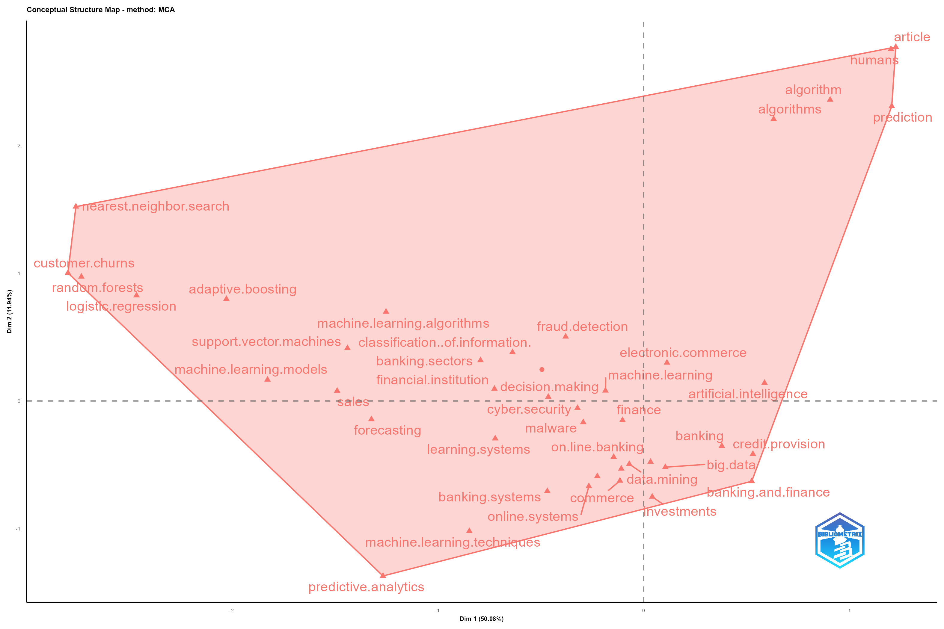

Figure 16: Conceptual structure map

The conceptual structure map, generated using the Multiple Correspondence Analysis (MCA) method in Biblioshiny, provides an insightful visualization of key themes and topics in the research domain of AI/ML applications in banking and finance. The map highlights clusters of closely related terms, revealing the central focus areas and interconnections within the existing literature.

The right-hand side of the map is dominated by general themes such as "artificial intelligence," "finance," "prediction," and "machine learning." These broad terms indicate the overarching interest of the academic community in applying AI and ML techniques to enhance decision-making, risk management, and predictive analytics in banking. Adjacent terms such as "data mining," "big data," "banking systems," and "credit provision" further emphasize the growing reliance on data-driven approaches in financial services.

On the left side of the map, technical terms like "random forests," "logistic regression," "adaptive boosting," and "support vector machines" highlight the specific machine learning algorithms commonly employed in financial studies. The inclusion of terms like "customer churns," "fraud detection," and "cyber security" reflects key application areas where these models are used to improve banking services.

The clustering of terms such as "online banking," "e-commerce," and "finance" suggests a strong connection between technological advancements and digital banking solutions. Additionally, the presence of terms like "decision making," "learning systems," and "classification of information" underscores the importance of leveraging AI and ML for optimizing processes within financial institutions.

Overall, the conceptual structure map illustrates a comprehensive view of the existing research landscape, identifying critical areas where AI and ML are being explored in banking. This visualization highlights the interdisciplinary nature of the research, bridging topics related to technology, data analytics, cybersecurity, and financial services, thus providing a foundation for identifying emerging trends and potential research gaps.

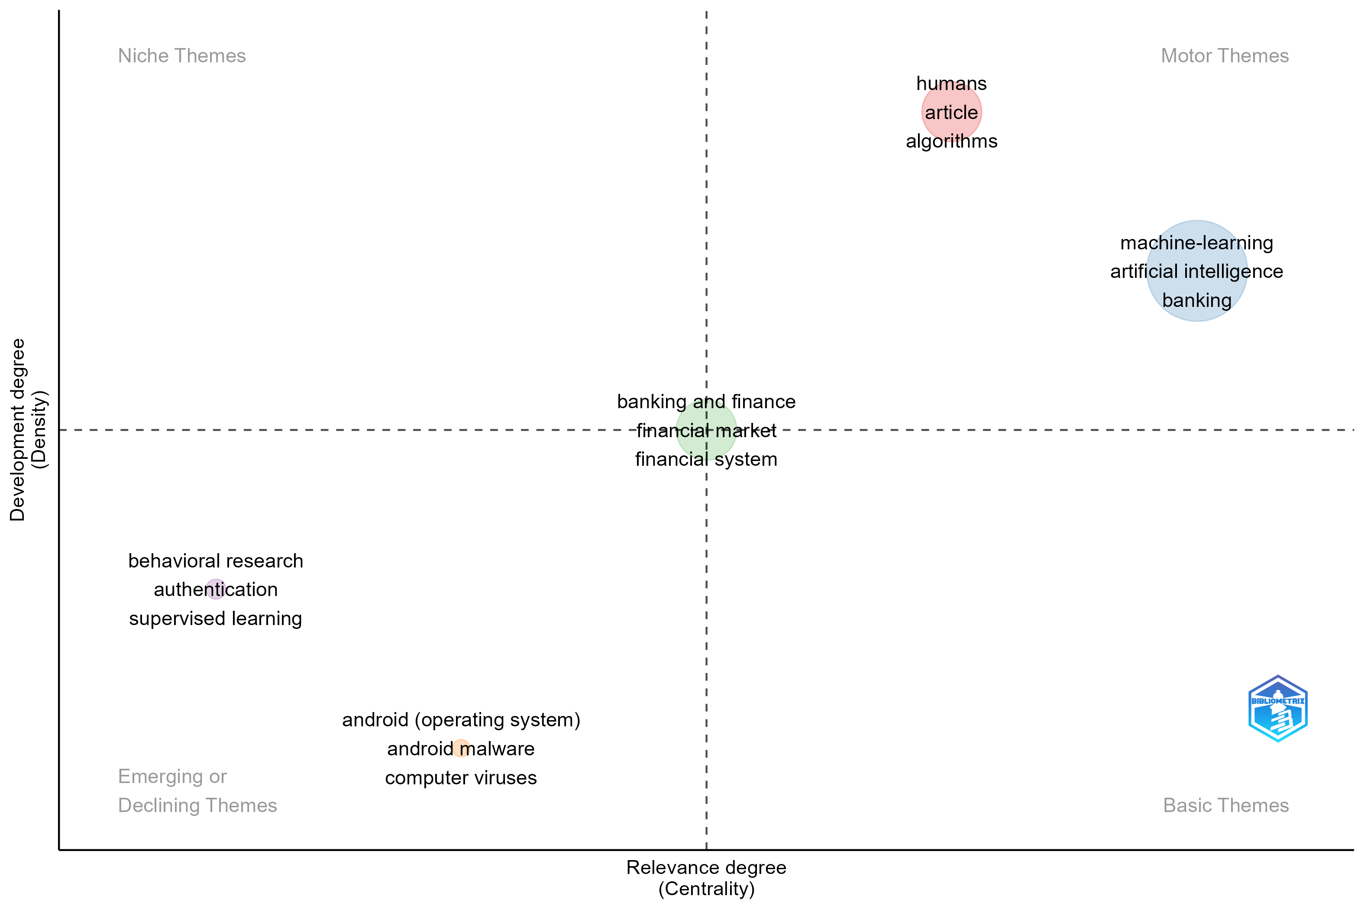

Figure 17: Thematic map

Figure 17 present a thematic map categorizing research themes by centrality and density. Core themes like decision-making, learning systems, and risk assessment are highly developed and central to the field, while niche themes such as biometrics and natural language processing present opportunities for future exploration. Motor themes, including random forests and logistic regression, highlight rapidly evolving areas of high relevance and development.

The combined analysis provides a comprehensive overview of both established and emerging areas, enabling researchers to align their efforts with high-impact topics. The transition to VOSviewer will complement these findings by visualizing collaborations and key relationships within the research community, offering deeper insights into influential authors, institutions, and research clusters in AI/ML for banking.

**Credit Risk**

The literature on credit risk emphasizes the application of advanced machine learning models and hybrid approaches to enhance predictive accuracy and decision-making in financial institutions. Techniques such as support vector machines, neural networks, and decision trees have been widely adopted, demonstrating their efficacy in improving credit risk modeling Chang et al., 2024; Chen, 2020; Sigrist & Leuenberger, 2023. Hybrid frameworks, including adaptive neuro-fuzzy inference systems and ensemble models, address challenges related to data imbalance and model bcardias, offering improved performance in financial contexts Ahmed et al., 2023; Kumar et al., 2023. The role of system log data and explainable machine learning has been explored to enhance the interpretability and scalability of credit scoring models Hu et al., 2021; Kyeong et al., 2022; Nazemi & Fabozzi, 2024.

Furthermore, studies comparing machine learning methods have highlighted the importance of conservative and robust approaches in online credit scoring Ashofteh & Bravo, 2021; Khandani et al., 2010; Munkhdalai et al., 2019.

The integration of machine learning techniques with consumer-tradeline and macroeconomic variables has been used to predict delinquency and analyze risk management practices Butaru et al., 2016. Other contributions focus on incorporating macroeconomic variables and firm-specific attributes into credit risk assessments, while machine learning interpretability has been applied to stress scenario analysis and non-performing loan dynamics Ari et al., 2021; Bueff et al., 2022. Quantile neural networks and profit modeling frameworks provide insights into creditor recovery and return on investment in artificial intelligence for risk management Fraisse & Laporte, 2022; Kellner et al., 2022; Krivorotov, 2023. Methodologies like the reinforced urn process have also been employed to model recovery rates, enhancing decision-making strategies in the banking sector Cheng & Cirillo, 2018. These advancements underscore the potential of tailored predictive models and real-time data integration to mitigate credit risk effectively. Future research calls for interdisciplinary collaboration to address existing challenges and refine models for dynamic and scalable applications in diverse financial settings.

**Customer Churn Prediction and Retention**

The literature on customer churn prediction and retention highlights the critical role of machine learning and statistical models in identifying churn patterns and developing effective retention strategies. Neural networks and statistical methods have been compared to understand their predictive capabilities, with findings suggesting the superiority of machine learning in addressing customer attrition challenges Altman et al., 1994; Singh et al., 2024. Studies utilizing enhanced rule-based algorithms and advanced segmentation methodologies demonstrate improved accuracy in predicting churn within banking and financial sectors Al-Sultan & Al-Baltah, 2024; Dawood et al., 2019; Smeureanu et al., 2013. Research further underscores the importance of integrating behavioral, transactional, and demographic data to develop targeted retention strategies, with models offering deeper insights into customer preferences and satisfaction levels Gkonis & Tsakalos, 2024;Zeinalizadeh et al., 2015.

Issues concerning data heterogeneity, the scalability of models, and the generalizability of predictions across diverse industries have been recognized. Studies emphasize the value of hybrid approaches combining artificial intelligence and traditional statistical methods, particularly in enhancing model interpretability and scalability de de Lima Lemos et al., 2022; Tékouabou et al., 2022. Practical applications highlight the potential of AI-driven frameworks to refine customer segmentation and improve data-driven marketing strategies, with implications for fostering customer loyalty and proactive engagement Alshurideh et al., 2024; Torrens & Tabakovic, 2022. Future research directions advocate for the development of explainable AI models, the incorporation of real-time behavioral data, and the use of predictive frameworks to address churn challenges in dynamic and competitive industries.

**Technology Adoption**

The literature on technology adoption examines factors driving the uptake of emerging technologies like artificial intelligence, machine learning, and blockchain in banking. Trust, perceived usefulness, and ease of use are consistently identified as critical factors shaping user acceptance, as demonstrated in studies examining AI-enabled platforms and digital banking adoption Mi Alnaser et al., 2023; Carbo-Valverde et al., 2020; Cavus et al., 2021; Noreen et al., 2023. Generational and socio-cultural differences also play a significant role, with research focusing on Generation Z’s attitudes towards AI and millennial loyalty to AI-driven services Hameed & Nigam, 2023; Suhartanto et al., 2022. Broader societal impacts of AI and metaverse-enabled innovations in banking have been analyzed, providing new perspectives on customer engagement and service delivery Mohamed & Faisal, 2024; Schreieck et al., 2024. Specific contexts such as mobile banking adoption and digital marketing in financial services have highlighted the need for trust-building and tailored strategies to address data privacy and infrastructure challenges Abu-Taieh et al., 2022; Çallı, 2023; Otopah et al., 2024.

Quantitative surveys, hybrid research models, and machine learning approaches have been employed to examine adoption behaviors, with case studies from Asia, Europe, and the Middle East providing rich insights Lee & Chen, 2022; Luo et al., 2020; Mogaji & Nguyen, 2022. Findings emphasize the role of continuous intention to use AI-driven platforms, with studies analyzing value co-creation processes and AI features in mobile banking Bhatnagr & Rajesh, 2024; Bhatnagr et al., 2024; E. H. Manser Payne et al., 2021. Research also identifies the differential impact of constructs like relative advantage, trust, and attitudes toward AI in mobile versus AI-enabled banking, calling for further exploration of user comfort and perceptions E. Manser Payne et al., 2018. The influence of digital platform strategies and political ideologies on adoption behaviors has also been explored Riedel et al., 2022; Schreieck et al., 2024. Practical implications highlight the importance of targeted training programs and ethical AI frameworks to ensure adoption success while addressing societal concerns Ho & Chow, 2024; Rahman et al., 2023. Future directions advocate for interdisciplinary collaboration among academia, industry, and policymakers to maximize the societal and organizational benefits of technology adoption Mohamed & Faisal, 2024; Salem & Rassouli, 2024.

**Bank Failure**

The literature on bank failure prediction highlights significant advancements in using statistical and machine learning models to improve forecasting accuracy. Early warning systems and rare event detection techniques have been studied extensively, demonstrating the effectiveness of machine learning approaches such as logit models and neural networks Beutel et al., 2019; Coffinet & Kien, 2019. Research highlights the importance of macroeconomic indicators and firm-specific attributes in developing predictive models, while advanced methods address challenges such as data imbalances Petropoulos et al., 2020; Shrivastav, 2019. Cost-sensitive frameworks have also been proposed to enhance model performance in predicting bank failures, as seen in recent studies Ekinci & Sen, 2024.

Broader perspectives on banking crises have explored distrust among both banked and unbanked populations, offering insights into consumer behavior and risk assessment Grable et al., 2023.

Other contributions focus on computational techniques such as genetic algorithms, which are applied to analyze corporate financial distress Varetto, 1998. Studies have also demonstrated the potential of hybrid frameworks, such as fuzzy refinement and artificial intelligence models, to refine predictions over the long term and adapt to changing conditions Behbood et al., 2014; Erdal & Ekinci, 2013; Shie et al., 2012. Moreover, stress testing and forecasting methods for bank failures have been enhanced through the integration of machine learning and macroeconomic analysis Gogas et al., 2018. Finally, improvements in bankruptcy prediction models have been achieved by incorporating real-time data and exploring advanced implementation techniques Le & Viviani, 2018.

**Fraud Detection and Anti-Money Laundering (AML)**

Research on fraud detection and anti-money laundering (AML) employs advanced AI and ML techniques to address sophisticated threats in banking. Imbalanced classification, a critical challenge in fraud detection, has been addressed through innovative machine learning models designed to improve predictive accuracy in banking contexts Ruchay et al., 2023. Real-time fraud detection frameworks, such as those using Self-Organizing Maps (SOM), have been developed to combat online credit card fraud effectively Quah & Sriganesh, 2008. Automated feature selection and classification techniques have been shown to enhance the detection of fraudulent banking relationships, offering a promising direction for AML systems González-Carrasco et al., 2019.

Decision-support tools like BankSealer integrate human expertise with ML algorithms to detect anomalies more effectively, particularly in online banking environments Carminati et al., 2015. AI models have also been adapted to address dynamic fraud patterns and improve fraud prevention frameworks through deep learning methodologies Alarfaj & Shahzadi, 2024; Kim et al., 2022. Insights into the behavioral characteristics of fraudulent transactions have further refined detection algorithms, highlighting the importance of tailored ML models for banking fraud Can et al., 2020.

In the realm of wallet-based transactions, fraud prevention has been enhanced using predictive analytics, demonstrating the efficacy of customized AI frameworks Iscan et al., 2023. Feature engineering and preprocessing strengthen the scalability and robustness of banking fraud detection systems Hashemi et al., 2023. Predictive modeling has also been extended to identify patterns in money laundering activities, employing ML to process complex financial data effectively Lokanan, 2024. Additionally, comparative analyses of various ML algorithms have identified key approaches to optimize AML systems in banking environments Kumar et al., 2022.

Ethical concerns, including algorithmic biases and data privacy, have been consistently raised, underscoring the need for explainable AI and ethical oversight in these systems Bansal et al., 2024. Future research directions propose integrating temporal data, enhancing real-time analytics, and leveraging advanced deep learning techniques to build more responsive and accurate fraud detection frameworks Mytnyk et al., 2023; Ruchay et al., 2023.

**Customer Service Automation and Personalization**

To automate and personalize customer interactions banks use AI, case-based reasoning, and machine learning that leads to improved efficiency and engagement. Studies emphasize the role of AI in driving technical efficiency and improving customer retention by addressing user-specific needs dynamically Mor & Gupta, 2021; Nguyen et al., 2021; Piotrowski & Orzeszko, 2023. Predictive models, including deep learning systems, have been successfully utilized to optimize cross-selling opportunities and deliver real-time support in banking and related sectors (Boustani et al., 2024) ; Sheth et al., 2022. Similarly, hybrid approaches integrating traditional statistical models with AI techniques have proven effective in advancing decision-making systems Castelli et al., 2016; (Liu et al., 2024) .

The use of natural language processing (NLP) and machine learning has brought new focus to classifying banking transaction descriptions, an area previously overlooked. Case-based reasoning systems like CEBRA leverage contextual and historical data to provide personalized service recommendations, enhancing customer satisfaction Hernández-Nieves et al., 2021. Research highlights the potential of short-text classification models, such as those combining support vector machines and similarity detection methods, in improving customer experience and personal finance management Garcia-Mendez et al., 2020. These approaches align closely with the needs for ethical AI deployment and scalable solutions across industries Bouhia et al., 2022; N. Boustani et al., 2024. Privacy concerns, a growing area of focus, have also been identified as a significant barrier, requiring careful handling to maintain trust in AI-powered services Bouhia et al., 2022; Chaouali et al., 2024.

Applications extend beyond banking to include domains like healthcare and retail, where technologies like face recognition systems and robo-advisors have transformed service delivery Aw et al., 2024; Nosrati et al., 2024. However, challenges such as ethical governance, the integration of disruptive technologies, and limitations in legacy systems remain pervasive, underlining the need for strategic interventions Alghadi et al., 2024. Addressing financial anxiety through AI-driven support tools and ensuring justice in robo-advisory services are among the key focus areas for enhancing customer trust and loyalty Aw et al., 2024; Ghazwani et al., 2022. Future research should explore ways to balance technological advancements with human-centric service paradigms, ensuring fairness, accessibility, and satisfaction across customer touchpoints Iman et al., 2023. These studies collectively highlight the transformative potential of AI in delivering personalized, efficient, and ethically sound customer service solutions, driving the field toward a more innovative future.

**Credit Scoring and Risk Assessment**

Recent research highlights the impact of AI and ML in enhancing credit scoring and risk assessment accuracy. Studies highlight the superiority of ML models like Random Forests, Support Vector Machines (SVM), and Gradient Boosting algorithms over traditional methods such as logistic regression, particularly in predicting credit ratings and defaults Alonso-Robisco & Carbó, 2022; W.-H. Chen & Shih, 2006; Li et al., 2020. For example, the application of XGBoost in calculating regulatory capital savings has demonstrated reductions of up to 17%, showcasing the economic value of advanced ML models Alonso-Robisco & Carbó, 2022. Similarly, the Support Vector Machine approach in Taiwan’s banking industry achieved superior accuracy by integrating market information and shareholder support into models W.-H. Chen & Shih, 2006. Locally linear model tree algorithms (LOLIMOT) have also emerged as a novel approach, significantly enhancing prediction accuracy by integrating data fusion and feature selection techniques Siami et al., 2014. Explainable AI (XAI) techniques have gained traction in regulatory-compliant credit scoring, with models like LightGBM combined with SHAP offering both high predictive power and transparency de Lange et al., 2022. Fairness in credit scoring is another critical concern, with studies highlighting trade-offs between profitability and fairness. Empirical results suggest that fairness constraints can be integrated into ML models with minimal impact on profitability, paving the way for more ethical lending practices Kozodoi et al., 2022. Incorporating macroeconomic factors and dynamic datasets has also been a focus, as models become increasingly adept at handling complex relationships. Advanced ML techniques like AdaBoost, Decision Trees, and Artificial Neural Networks have been effective in credit card default predictions, achieving significant accuracy improvements Wahab et al., 2024. However, challenges such as dataset imbalance and interpretability remain critical, requiring further refinement of hyperparameter optimization and feature selection methods Laborda & Ryoo, 2021; Wahab et al., 2024. Finally, interpretable ML methods have shown promise in addressing challenges in corporate bond recovery rate prediction, effectively bridging the gap between accuracy and clarity while providing actionable insights for risk assessment Y. Chen et al., 2024. Collectively, these studies underscore the importance of leveraging advanced AI/ML methods to enhance credit scoring accuracy while addressing interpretability, fairness, and regulatory compliance. Future research should explore the integration of diverse datasets, the refinement of fairness constraints, and the development of ensemble models to achieve even greater precision in risk assessment.

**Financial Crime Detection and Cybersecurity**

Advances in cybersecurity have driven the development of innovative frameworks for financial crime detection. Research has emphasized behavioral analysis for fraud prevention, with a framework for1 continuous authentication using user behavior patterns addressing real-time fraud detection challenges Estrela et al., 2021. Complementing this, another study proposed Emotional Artificial Neural Networks integrated with Gaussian models, effectively mitigating insider threats by analyzing human behavior in cyber environments Cavus et al., 2022. The integration of machine learning techniques with cybersecurity frameworks has also been explored, demonstrating their potential to enhance the detection of sophisticated threats, such as TrickBot malware and fraudulent transactions, by focusing on behavioral and contextual patterns Bai et al., 2021; Gezer et al., 2019. In parallel, socially responsible and data-intensive innovations have gained prominence, advocating for ethical and equitable practices in designing cybersecurity systems that safeguard financial institutions while promoting trust among users Aitken et al., 2021. Real-time DDoS (Distributed Denial of Service) detection has improved with machine learning, ensuring stronger system defenses Islam et al., 2022. Additionally, cyber kill chain-based taxonomies have been proposed to map attack trajectories, addressing persistent threats like advanced persistent threats (APTs) and banking trojans, and improving defense mechanisms Kiwia et al., 2018. Sustainability in cybersecurity has also emerged as a key focus, with studies exploring machine learning applications to develop structured frameworks for detecting insider-led frauds, thereby balancing robust security with long-term effectiveness Chhabra Roy & Prabhakaran, 2023. Another study has highlighted the importance of integrating holistic approaches in cybersecurity, emphasizing the need for comprehensive strategies that align with the evolving nature of financial crimes Asmar & Tuqan, 2024. Together, these contributions underline the importance of combining innovative behavioral analysis Cavus et al., 2022; Estrela et al., 2021; Gezer et al., 2019, machine learning integration Bai et al., 2021; Islam et al., 2022, and socially responsible practices Aitken et al., 2021 to protect financial ecosystems effectively.

**Bank Performance Management**

The domain of bank performance management and cybersecurity has witnessed extensive research focusing on innovative frameworks and analytical tools to enhance efficiency, security, and adaptability. On the performance management side, integrating data analytics and machine learning has been pivotal in improving decision-making processes, with studies emphasizing the need to address challenges like data quality, analytics talent, and regulatory conditions in global banking contexts Chang et al., 2024; Kumar et al., 2022. Political uncertainty has been identified as a significant determinant of banking performance, demonstrating an inverted U-shaped relationship with financial outcomes, further emphasizing the dynamic interplay between external events and internal performance Qian et al., 2024.

In Islamic banking, research highlights its resilience in various financial environments while identifying inefficiencies linked to governance and operational practices, emphasizing the importance of societal and institutional factors in shaping outcomes Polyzos et al., 2023; Saâdaoui & Khalfi, 2024. The application of intelligent prediction systems using dynamic weights has further provided insights into improving decision-making in banking operations Li et al., 2021.

Machine learning approaches have been used to predict and assess banking efficiency, focusing on profitability, liquidity, and cost management. Studies highlight the application of feature selection and predictive models like support vector machines, ensemble methods, and neural networks, showcasing their superior performance in evaluating bank efficiency and insolvency risks Assous, 2022; Wei et al., 2021. Comparative analyses reveal the role of regional and cultural factors in shaping banking practices, with studies addressing early warning indicators and macroeconomic influences on bank classification and profitability Meitei et al., 2022; Rai et al., 2023. Frameworks for continuous performance evaluation, leveraging adaptive regression techniques and decision support systems, provide actionable insights for overcoming macroeconomic challenges and improving decision-making processes Bolívar et al., 2023; Doumpos & Zopounidis, 2010. In parallel, cybersecurity research has addressed the growing threats to financial institutions, emphasizing behavioral analysis and advanced machine learning techniques to enhance fraud detection. Continuous authentication frameworks based on user behavior have been proposed to mitigate unauthorized access risks, while innovative models like Emotional Artificial Neural Networks have been applied to counter insider threats Ozgur et al., 2021; Shilbayeh & Grassa, 2024. Research further explores the ethical and practical implications of data usage, highlighting the importance of socially responsible approaches to cybersecurity in financial systems González-Rossano et al., 2023; Rantanen et al., 2020. Advanced detection techniques, including feature engineering for DDoS attacks and malware identification, underscore the importance of machine learning in ensuring real-time resilience against cyber threats ; Puli et al., 2024. Taxonomy-based approaches such as the Cyber Kill Chain (CKC) framework provide critical insights into addressing advanced persistent threats and mapping attack trajectories Li et al., 2021. Sustainability and innovation also play critical roles in banking and cybersecurity. Integrating machine learning for sustainable cybersecurity frameworks has addressed insider fraud risks while emphasizing the need for scalable, long-term solutions Assous, 2022; Ozgur et al., 2021. Holistic approaches to cybersecurity highlight the necessity of combining technical advancements with strategic considerations to address the evolving nature of financial crimes. Novel predictive models for evaluating banking performance have introduced practical methods for aligning operational efficiency with macroeconomic realities Bolívar et al., 2023; González-Rossano et al., 2023. These studies highlight the various challenges and opportunities in bank performance and cybersecurity. Future research should explore the integration of adaptive machine learning techniques, the development of equitable and sustainable frameworks for fraud prevention, and the long-term implications of macroeconomic trends and political uncertainty on banking operations. These efforts support the development of robust, secure, and efficient financial systems suited to an increasingly digital and interconnected world.

**Portfolio and Wealth Management**

AI has been applied to model negotiation paradigms, enabling conflict resolution and facilitating decision-making in complex financial environments Sadananda & Acharya, 1993. Behavioral models powered by AI improve credit and investment decision-making by incorporating causal reasoning and adaptable algorithms, ensuring robust assessments even in uncertain scenarios Rodgers et al., 2023. The utilization of AI-driven automated advisors has exhibited promise for providing customized financial counsel at diminished expenses. Hybrid models that combine automated processes with human interactions address diverse customer needs effectively Barile et al., 2024. Consumer preferences for human advisors remain strong in high-involvement financial decisions, although AI proves efficient in routine tasks like robo-advisors and chatbots Northey et al., 2022. AI’s role in balancing technological innovation with security concerns has been highlighted through frameworks integrating digital transformation and cybersecurity in banking operations Rodrigues et al., 2022. The combination of Data Envelopment Analysis and Artificial Neural Networks (DEA-ANN) has been used to benchmark bank branch performance, showcasing its utility in identifying efficiency improvements and setting realistic targets Tsolas et al., 2020. These advancements reflect the transformative potential of AI in enhancing decision-making, customer experience, and operational resilience in the banking sector.

**Liquidity Risk**

Liquidity risk, the potential inability of a bank to meet financial obligations without significant losses, demands advanced tools for effective management in today’s dynamic financial landscape. ANNs excel at learning from historical data to approximate risk functions and identify key drivers, while BNs provide nuanced insights into the relationships between risk factors and offer robust predictions, especially in scenarios with incomplete data Tavana et al., 2018. Ensemble models like RUSBoost and advanced techniques such as extreme gradient boosting (XGBoost) enhance early warning systems and stress testing capabilities by simulating scenarios and identifying potential vulnerabilities Guerra et al., 2022; Tarkocin & Donduran, 2024.

Research suggests that bank culture can mitigate the negative impact of regulatory capital on liquidity creation, highlighting the importance of integrating cultural considerations into AI models to better understand risk dynamics Thi Nguyen et al., 2024. This alignment between technical innovations and cultural factors has drawn the attention of regulators, who are incorporating cultural assessments into supervisory frameworks for more comprehensive oversight Thi Nguyen et al., 2024.

**Predictive Analytics and Market Forecasting**

ML has emerged as a transformative tool in banking, enabling improved efficiency and decision-making across diverse domains. Hybrid models that combine Deep Belief Networks and ARIMA have been found effective for forecasting bank transactions, addressing challenges such as error minimization and feature extraction Kullaya Swamy & Sarojamma, 2020. The integration of ML with robust optimization techniques enhances cash logistics by accurately forecasting cash demands and optimizing transportation schedules to reduce costs and improve reliability López Lázaro et al., 2018.

A class membership-based ML framework improves telemarketing campaigns in banking, achieving high prediction accuracy while handling data heterogeneity effectively Tékouabou et al., 2022. Similarly, ML pipelines for time series forecasting have proven useful for optimizing operations such as ATM cash management and call center load balancing, leading to better resource allocation Gorodetskaya et al., 2021.

ML has also shown its potential in loan approval processes, where ensemble models incorporating SMOTE for data balancing achieve high accuracy and streamline the evaluation of applicants Uddin et al., 2023. Automated ML approaches for branch performance evaluation and target setting have addressed challenges like seasonality and periodicity, leading to a 10% improvement in target success rates Met et al., 2023. These advancements highlight the growing role of ML in addressing various challenges in banking, from operational optimization to customer engagement, showcasing its versatility and transformative potential across the sector.

**Operational Risk**

AI/ML can model operational risks by analyzing large datasets to identify patterns and predict potential risk events, which traditional methods might overlook. For instance, Bayesian networks, a variant of probabilistic graphical models, have been used in operational risk modeling, facilitating the integration of expert assessment and the modification of models as novel data emerges, augmenting the predictive efficacy of risk management systems A. Sanford & Moosa, 2015; A. D. Sanford & Moosa, 2012. Using AI in operational risk management is also seen in the development of risk accounting frameworks that employ AI-enabled digital architectures to improve risk data aggregation and analysis, providing a more granular view of risk exposures Butler & Brooks, 2024. Using AI and ML in this field brings challenges, such as risks from errors in model design or use. This causes robust model validation processes to ensure accuracy and fairness, as highlighted by concerns over biases in training data and the interpretability of AI models Cosma et al., 2023. The rapid evolution of digital technologies requires banks to continuously adapt their risk management frameworks to address new threats and vulnerabilities, emphasizing the need for a paradigm shift in how operational risks are managed Butler & Brooks, 2024. Despite challenges, AI and ML help banks predict and manage risks in complex financial systems.

**Systemic Risk**

The systemic risk within the banking sector constitutes a significant issue attributable to the interrelated framework of financial institutions, wherein the collapse of a single entity has the potential to initiate a series of defaults, ultimately resulting in extensive financial instability. This phenomenon is frequently intensified by the intricate network configurations of interbank markets, which can magnify the dissemination of systemic risk through contagion mechanisms. To illustrate, the bankruptcy of Lehman Brothers in 2008 and the Greek sovereign debt crisis revealed how systemic risks can rapidly propagate within financial systems, mandating governmental intervention to restore market stability. Theoretical frameworks, such as those posited by Yu & Zhao, 2020, underscore the significance of comprehending the interbank network’s architecture, encompassing elements such as connectivity and concentration, which affect the system’s capacity to mitigate perturbations. Furthermore, machine learning methodologies, such as Gradient Boosting Decision Trees, have been utilized to augment the prediction and management of systemic risk by scrutinizing network structures and identifying pivotal risk factors Yu & Zhao, 2020. In addition, systemic risk measures like CoVaR and SRISK have been developed to quantify the risk of financial systems under distress, incorporating macroeconomic variables to improve predictive accuracy Liu & Pun, 2022. These measures help identify systemically important financial institutions and guide macro-prudential regulation. However, challenges remain in capturing the dynamic and often unpredictable nature of systemic events, as crises are typically unique and characterized by unknown unknowns Daníelsson et al., 2022. The procyclicality of financial institutions, driven by harmonized risk perceptions and AI-based risk management systems, can further amplify systemic risk by encouraging similar risk-taking behaviours across institutions. Furthermore, the incorporation of environmental, social, and governance (ESG) criteria into banking methodologies, exemplified by green credit initiatives, is increasingly recognized as a mechanism to bolster financial stability and sustainability; however, this paradigm shift engenders novel risk dimensions that necessitate meticulous management (Ionescu et al., 2023). In summary, the effective management of systemic risk within the banking sector mandates a comprehensive strategy that integrates sophisticated risk assessment methodologies, stringent regulatory supervision, and pioneering financial practices to diminish the risk of financial contagion and to fortify the resilience of the banking infrastructure.

**Operational Efficiency and Process Automation**

The integration of AI / ML in banking operations significantly enhances operational efficiency and process automation. AI technologies like expert systems and intelligent agents, are increasingly utilized in banking to automate routine tasks, thereby improving productivity and reducing costs. For instance, AI-driven accounting systems in Jordanian banks have demonstrated improved efficiency by automating data analysis and interpretation, which traditionally required significant human intervention Al-Jarrah et al., 2024. Machine learning models like support vector machines (SVM), have been applied to optimize banking processes, such as teller operations, by dynamically adapting control policies based on performance metrics. This approach reduces the time required for transaction authorizations and enhances customer satisfaction by minimizing delays Tay and Mourad, 2020. Furthermore, the use of ML in detecting banking malware, such as Zeus, highlights the potential of AI in safeguarding banking operations against cyber threats, thereby maintaining operational integrity and efficiency Kazi et al., 2023. The strategic application of AI in banking also involves restructuring internal networks and outsourcing services to optimize resource allocation and minimize risks, as demonstrated in studies focusing on the Italian banking sector Baldassarre et al., 2024. These advancements underscore the transformative impact of AI and ML on banking operations, facilitating a shift towards more automated, efficient, and secure processes. These technologies empower banks to refine their operations and improve service delivery, fostering better efficiency and stronger customer relationships.

**Regulatory Compliance and Risk Management**

AI/ML has become a vital tool in the banking sector for ensuring regulatory compliance and managing risks effectively. In regulatory compliance, ML models such as Random Forest and Adaptive Lasso have proven to be more accurate than traditional methods in predicting key variables like Net Charge-Offs (NCO) and Pre-Provision Net Revenue (PPNR), which are critical for stress testing and assessing capital adequacy Moffo, 2024. ML algorithms like Random Forest and XGBoost are widely used in Early Warning Systems (EWS) to predict bank failures and systemic risks, enabling regulators to take proactive measures to maintain financial stability Guerra et al., 2022. These models allow for continuous monitoring of risk profiles, improving adherence to regulatory standards, and enhancing supervisory frameworks.

In risk management, ML is employed for assessing and forecasting, credit, market, and operational risks. ML models process large datasets to identify patterns and predict future vulnerabilities, aiding in the development of robust risk strategies Wong and Wong, 2021. For example, ML has been used to predict the BIS capital adequacy ratio, ensuring compliance with international banking standards Park et al., 2021. ML enhances data quality by detecting and correcting anomalies, supporting compliance with regulations like BCBS 239, which emphasize accurate and timely data for risk management Wong and Wong, 2021. Despite these benefits, challenges, such as the interpretability of complex ML models remain. Developing explainable AI techniques is essential to gaining trust among stakeholders and meeting regulatory expectations Guerra et al., 2022. These advancements illustrate ML’s transformative role in creating more resilient and compliant banking systems.

**Conclusion and Future Directions**

**Research Insights**

The analysis of AI/ML in banking highlights key advancements in fraud detection, customer engagement, regulatory compliance, and risk management. This study explores how these technologies are being applied across various banking functions to address operational challenges and improve outcomes.

AI and ML have been adopted to tackle key challenges, such as fraud prevention, credit risk management, and customer service enhancement. For instance, in fraud detection and anti-money laundering (AML), machine learning models effectively identify suspicious transactions using anomaly detection, surpassing traditional methods by providing real-time prevention capabilities. Similarly, AI-driven credit risk models offer more accurate borrower assessments by analyzing large datasets and uncovering complex patterns. Predictive models assist banks in managing customer churn by developing retention strategies based on behavior insights, reducing attrition rates. In customer relationship management (CRM), chatbots and virtual assistants streamline interactions, personalize services, and reduce response times, ultimately enhancing customer satisfaction while lowering operational costs.

The study also investigates how bibliometric and thematic analyses contribute to identifying research trends and future directions in AI/ML for banking. These analyses reveal collaboration patterns, influential authors, and thematic clusters, providing a structured approach to understanding the research landscape. They highlight core themes, such as fraud detection, CRM, predictive analytics, and operational efficiency, while uncovering critical gaps in the literature.

Emerging trends in AI/ML research point to growing attention on cybersecurity solutions to protect sensitive data and prevent breaches. Predictive analytics models are increasingly used to expect customer behavior and market risks, enabling more informed decision-making. Regulatory compliance tools are developing to automate monitoring processes, reducing penalties, and ensuring adherence to legal frameworks. The concept of explainable AI (XAI) is gaining prominence, with financial institutions seeking to enhance transparency and trust in AI-driven decisions by demystifying complex models.

**Further Pathways and Research Gaps**

Addressing the identified gaps through interdisciplinary research will foster sustainable innovation in the banking sector. By integrating insights from computer science, finance, and ethics, future studies can ensure the responsible adoption of AI/ML technologies, improving operational efficiency, and enhancing customer experiences across financial institutions.

The critical research gaps identified include:

* *Unsupervised Learning Models:* There is limited use of unsupervised learning techniques in banking. These models have significant potential for anomaly detection, customer segmentation, and behavioral analysis, especially in scenarios where labeled data is scarce.
* *Ethical Concerns:* Addressing biases in AI models is essential to ensure fairness in AI-driven decisions. This is important in areas such as credit scoring and loan approvals, where biased algorithms can lead to discriminatory outcomes.
* *Real-Time Learning Systems:* Existing AI models primarily rely on historical data and lack the capability to adapt to dynamic, real-time inputs. Developing adaptive systems that process real-time data will improve decision-making accuracy and responsiveness.
* *Explainability and Interpretability:* Many AI models function as opaque "black boxes," making it challenging to understand their decision-making processes. Research into explainable AI (XAI) is critical for enhancing transparency, building trust, and ensuring compliance with regulatory requirements.

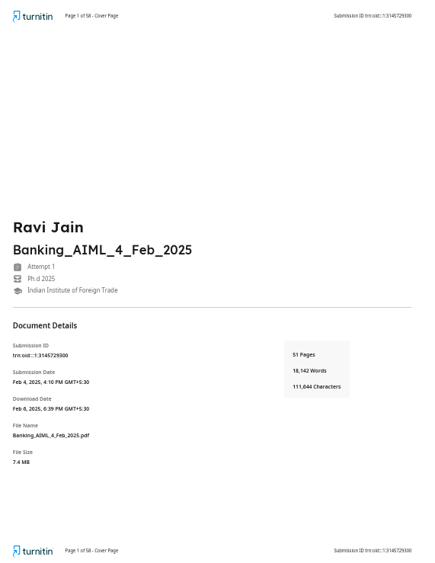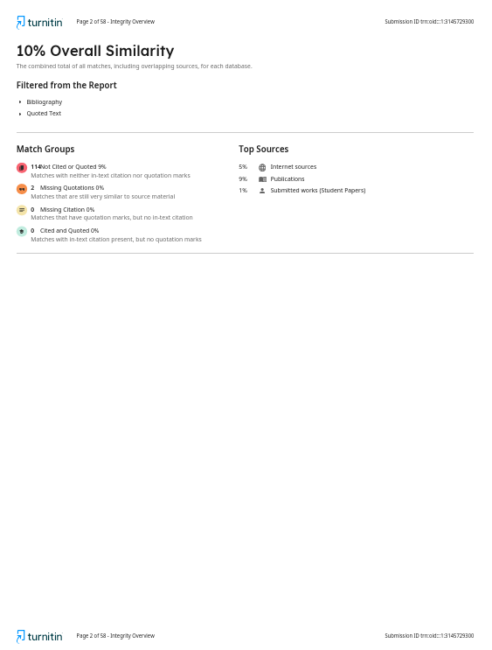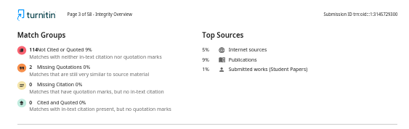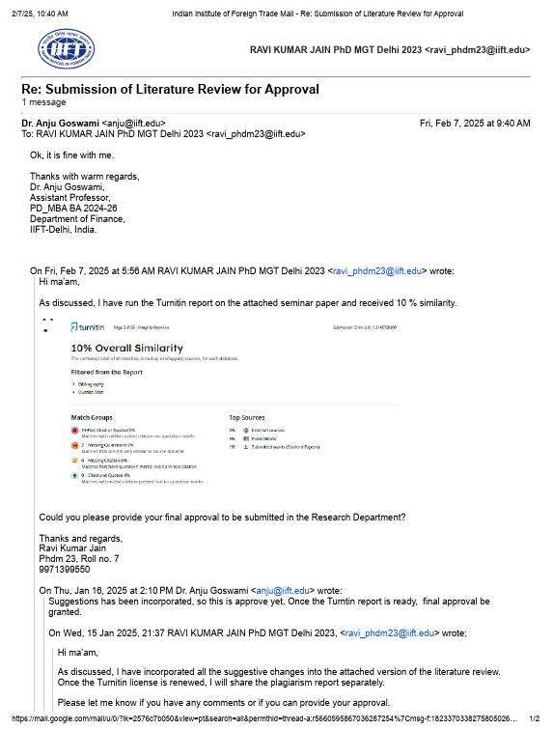

Abu-Taieh, E. M., AlHadid, I., Abu-Tayeh, S., Masa’deh, R., Alkhawaldeh, R. S., Khwaldeh, S., & Alrowwad, A. (2022). Continued Intention to Use of M-Banking in Jordan by Integrating UTAUT, TPB, TAM and Service Quality with ML. *Journal of Open Innovation: Technology, Market, and Complexity*, *8*(3), Article 3. <https://doi.org/10.3390/joitmc8030120>

Ahmed, I. E., Mehdi, R., & Mohamed, E. A. (2023). The role of artificial intelligence in developing a banking risk index: An application of Adaptive Neural Network-Based Fuzzy Inference System (ANFIS). *Artificial Intelligence Review*, *56*(11), Article 11. <https://doi.org/10.1007/s10462-023-10473-9>

Aitken, M., Ng, M., Horsfall, D., Coopamootoo, K. P. L., van Moorsel, A., & Elliott, K. (2021). In pursuit of socially-minded data-intensive innovation in banking: A focus group study of public expectations of digital innovation in banking. *Technology in Society*, *66*. <https://doi.org/10.1016/j.techsoc.2021.101666>

Alarfaj, F. K., & Shahzadi, S. (2024). Enhancing Fraud Detection in Banking with Deep Learning: Graph Neural Networks and Autoencoders for Real-Time Credit Card Fraud Prevention. *IEEE Access*. <https://doi.org/10.1109/ACCESS.2024.3466288>

Alghadi, M. Y., Alqudah, H., Lutfi, A., Ananzeh, H., Marei, A., Almaiah, M. A., & Al-Matari, Y. A. (2024). Enhancing cyber governance in Islamic banks: The influence of artificial intelligence and the moderating effect of Covid-19 pandemic. *International Journal of Data and Network Science*, *8*(1), Article 1. <https://doi.org/10.5267/j.ijdns.2023.9.023>

Al-Jarrah, M. F. M., Al Badarin, A. M. K., & Almohammad, M. Z. A.-L. (2024). The role of artificial intelligence in developing the accounting system in Jordanian Islamic banks. *International Journal of Data and Network Science*, *8*(4), Article 4. <https://doi.org/10.5267/j.ijdns.2024.5.010>

Alonso-Robisco, A., & Carbó, J. M. (2022). Can machine learning models save capital for banks? Evidence from a Spanish credit portfolio. *International Review of Financial Analysis*, *84*. <https://doi.org/10.1016/j.irfa.2022.102372>

Alshurideh, M., Al Kurdi, B., Hamadneh, S., Chatra, K., Snoussi, T., Alzoubi, H. M., Alzboun, N., & Ahmed, G. (2024). Utilizing Artificial Intelligence (AI) in enhancing customer-supplier relationship: An exploratory study in the banking industry. *Uncertain Supply Chain Management*, *12*(4), Article 4. <https://doi.org/10.5267/j.uscm.2024.5.005>

Al-Sultan, S. Y., & Al-Baltah, I. A. (2024). An Improved Random Forest Algorithm (ERFA) Utilizing an Unbalanced and Balanced Dataset to Predict Customer Churn in the Banking Sector. *IEEE Access*, 1–1. <https://doi.org/10.1109/ACCESS.2024.3395542>

Altman, E. I., Marco, G., & Varetto, F. (1994). Corporate distress diagnosis: Comparisons using linear discriminant analysis and neural networks (the Italian experience). *Journal of Banking and Finance*, *18*(3), Article 3. <https://doi.org/10.1016/0378-4266(94)90007-8>

Andronie, M., Iatagan, M., Uță, C., Hurloiu, I., Dijmărescu, A., & Dijmărescu, I. (2023). Big data management algorithms in artificial Internet of Things-based fintech. *Oeconomia Copernicana*, *14*(3), Article 3. <https://doi.org/10.24136/oc.2023.023>

Ari, A., Chen, S., & Ratnovski, L. (2021). The dynamics of non-performing loans during banking crises: A new database with post-COVID-19 implications. *Journal of Banking and Finance*, *133*. <https://doi.org/10.1016/j.jbankfin.2021.106140>

Ashfaq, T., Khalid, R., Yahaya, A. S., Aslam, S., Azar, A. T., Alsafari, S., & Hameed, I. A. (2022). A Machine Learning and Blockchain Based Efficient Fraud Detection Mechanism. *Sensors*, *22*(19), Article 19. <https://doi.org/10.3390/s22197162>

Ashofteh, A., & Bravo, J. M. (2021). A conservative approach for online credit scoring. *Expert Systems with Applications*, *176*. <https://doi.org/10.1016/j.eswa.2021.114835>

Ashta, A., & Herrmann, H. (2021). Artificial intelligence and fintech: An overview of opportunities and risks for banking, investments, and microfinance. *Strategic Change*, *30*(3), Article 3. <https://doi.org/10.1002/jsc.2404>

Asmar, M., & Tuqan, A. (2024). Integrating machine learning for sustaining cybersecurity in digital banks. *Heliyon*, *10*(17), Article 17. <https://doi.org/10.1016/j.heliyon.2024.e37571>

Assous, H. F. (2022). Prediction of Banks Efficiency Using Feature Selection Method: Comparison between Selected Machine Learning Models. *Complexity*, *2022*. <https://doi.org/10.1155/2022/3374489>

Aw, E. C.-X., Leong, L.-Y., Hew, J.-J., Rana, N. P., Tan, T. M., & Jee, T.-W. (2024). Counteracting dark sides of robo-advisors: Justice, privacy and intrusion considerations. *International Journal of Bank Marketing*, *42*(1), Article 1. <https://doi.org/10.1108/IJBM-10-2022-0439>

Bai, C., Han, Q., Mezzour, G., Pierazzi, F., & Subrahmanian, V. S. (2021). DBank: Predictive Behavioral Analysis of Recent Android Banking Trojans. *IEEE Transactions on Dependable and Secure Computing*, *18*(3), Article 3. <https://doi.org/10.1109/TDSC.2019.2909902>

Baldassarre, S., Bruno, G., Piccolo, C., & Ruiz-Hernández, D. (2024). Multi-channel distribution in the banking sector and the branch network restructuring. *Expert Systems with Applications*, *238*. <https://doi.org/10.1016/j.eswa.2023.122294>

Bansal, K., Paliwal, A. C., & Singh, A. K. (2024). Analysis of the benefits of artificial intelligence and human personality study on online fraud detection. *International Journal of Law and Management*. <https://doi.org/10.1108/IJLMA-08-2023-0198>

Barile, D., Secundo, G., & Bussoli, C. (2024). Exploring artificial intelligence robo-advisor in banking industry: A platform model. *Management Decision*. <https://doi.org/10.1108/MD-08-2023-1324>

Barone, M., Bussoli, C., & Fattobene, L. (2024). Digital financial consumers’ decision-making: A systematic literature review and integrative framework. *International Journal of Bank Marketing*. <https://doi.org/10.1108/IJBM-07-2023-0405>

Behbood, V., Lu, J., & Zhang, G. (2014). Fuzzy refinement domain adaptation for long term prediction in banking ecosystem. *IEEE Transactions on Industrial Informatics*, *10*(2), Article 2. <https://doi.org/10.1109/TII.2012.2232935>

Beutel, J., List, S., & von Schweinitz, G. (2019). Does machine learning help us predict banking crises? *Journal of Financial Stability*, *45*. <https://doi.org/10.1016/j.jfs.2019.100693>

Bhatnagr, P., & Rajesh, A. (2024). Artificial intelligence features and expectation confirmation theory in digital banking apps: Gen Y and Z perspective. *Management Decision*. <https://doi.org/10.1108/MD-07-2023-1145>

Bhatnagr, P., Rajesh, A., & Misra, R. (2024). Continuous intention usage of artificial intelligence enabled digital banks: A review of expectation confirmation model. *Journal of Enterprise Information Management*, *37*(6), Article 6. <https://doi.org/10.1108/JEIM-11-2023-0617>

Bolívar, F., Duran, M. A., & Lozano-Vivas, A. (2023). Business model contributions to bank profit performance: A machine learning approach. *Research in International Business and Finance*, *64*. <https://doi.org/10.1016/j.ribaf.2022.101870>

Borowicz, M. K. (2024). The data quality problem (in the European Financial Data Space). *International Journal of Law and Information Technology*, *32*(1), Article 1. <https://doi.org/10.1093/ijlit/eaae015>

Bouhia, M., Rajaobelina, L., PromTep, S., Arcand, M., & Ricard, L. (2022). Drivers of privacy concerns when interacting with a chatbot in a customer service encounter. *International Journal of Bank Marketing*, *40*(6), Article 6. <https://doi.org/10.1108/IJBM-09-2021-0442>

Boustani, N., Emrouznejad, A., Gholami, R., Despic, O., & Ioannou, A. (2024). Improving the predictive accuracy of the cross-selling of consumer loans using deep learning networks. *Annals of Operations Research*, *339*(1–2), Article 1–2. <https://doi.org/10.1007/s10479-023-05209-5>

Boustani, N. M. (2022). Artificial intelligence impact on banks clients and employees in an Asian developing country. *Journal of Asia Business Studies*, *16*(2), Article 2. <https://doi.org/10.1108/JABS-09-2020-0376>

Btoush, E. A. L. M., Zhou, X., Gururajan, R., Chan, K. C., Genrich, R., & Sankaran, P. (2023). A systematic review of literature on credit card cyber fraud detection using machine and deep learning. *PeerJ Computer Science*, *9*. <https://doi.org/10.7717/PEERJ-CS.1278>

Bueff, A. C., Cytryński, M., Calabrese, R., Jones, M., Roberts, J., Moore, J., & Brown, I. (2022). Machine learning interpretability for a stress scenario generation in credit scoring based on counterfactuals. *Expert Systems with Applications*, *202*. <https://doi.org/10.1016/j.eswa.2022.117271>

Butaru, F., Chen, Q., Clark, B., Das, S., Lo, A. W., & Siddique, A. (2016). Risk and risk management in the credit card industry. *Journal of Banking and Finance*, *72*, 218–239. <https://doi.org/10.1016/j.jbankfin.2016.07.015>

Butler, T., & Brooks, R. (2024). Time for a paradigm change: Problems with the financial industry’s approach to operational risk. *Risk Analysis*, *44*(6), Article 6. <https://doi.org/10.1111/risa.14240>

Çallı, L. (2023). Exploring mobile banking adoption and service quality features through user-generated content: The application of a topic modeling approach to Google Play Store reviews. *International Journal of Bank Marketing*, *41*(2), Article 2. <https://doi.org/10.1108/IJBM-08-2022-0351>

Can, B., Yavuz, A. G., Karsligil, E. M., & Guvensan, M. A. (2020). A closer look into the characteristics of fraudulent card transactions. *IEEE Access*, *8*, 166095–166109. <https://doi.org/10.1109/ACCESS.2020.3022315>

Carbo-Valverde, S., Cuadros-Solas, P., & Rodríguez-Fernández, F. (2020). A machine learning approach to the digitalization of bank customers: Evidence from random and causal forests. *PLoS ONE*, *15*(10 October), Article 10 October. <https://doi.org/10.1371/journal.pone.0240362>

Carminati, M., Caron, R., Maggi, F., Epifani, I., & Zanero, S. (2015). BankSealer: A decision support system for online banking fraud analysis and investigation. *Computers and Security*, *53*, 175–186. <https://doi.org/10.1016/j.cose.2015.04.002>

Castelli, M., Manzoni, L., & Popovič, A. (2016). An Artificial Intelligence System to Predict Quality of Service in Banking Organizations. *Computational Intelligence and Neuroscience*, *2016*. <https://doi.org/10.1155/2016/9139380>

Cavus, N., Mohammed, Y. B., Bulama, M., & Isah, M. L. (2023). Examining User Verification Schemes, Safety and Secrecy Issues Affecting M-Banking: Systematic Literature Review. *SAGE Open*, *13*(1), Article 1. <https://doi.org/10.1177/21582440231152379>

Cavus, N., Mohammed, Y. B., Gital, A. Y., Bulama, M., Tukur, A. M., Mohammed, D., Isah, M. L., & Hassan, A. (2022). Emotional Artificial Neural Networks and Gaussian Process-Regression-Based Hybrid Machine-Learning Model for Prediction of Security and Privacy Effects on M-Banking Attractiveness. *Sustainability (Switzerland)*, *14*(10), Article 10. <https://doi.org/10.3390/su14105826>

Cavus, N., Mohammed, Y. B., & Yakubu, M. N. (2021). An artificial intelligence‐based model for prediction of parameters affecting sustainable growth of mobile banking apps. *Sustainability (Switzerland)*, *13*(11), Article 11. <https://doi.org/10.3390/su13116206>

Chang, V., Hahm, N., Xu, Q. A., Vijayakumar, P., & Liu, L. (2024). Towards data and analytics driven B2B-banking for green finance: A cross-selling use case study. *Technological Forecasting and Social Change*, *206*. <https://doi.org/10.1016/j.techfore.2024.123542>

Chang, V., Xu, Q. A., Akinloye, S. H., Benson, V., & Hall, K. (2024). Prediction of bank credit worthiness through credit risk analysis: An explainable machine learning study. *Annals of Operations Research*. <https://doi.org/10.1007/s10479-024-06134-x>

Chaouali, W., Souiden, N., Aloui, N., Ben Dahmane Mouelhi, N., Woodside, A. G., & Ben Abdelaziz, F. (2024). Roles of barriers and gender in explaining consumers’ chatbot resistance in banking: A fuzzy approach. *International Journal of Bank Marketing*. <https://doi.org/10.1108/IJBM-03-2023-0153>

Chen, T.-H. (2020). Do you know your customer? Bank risk assessment based on machine learning. *Applied Soft Computing Journal*, *86*. <https://doi.org/10.1016/j.asoc.2019.105779>

Chen, W.-H., & Shih, J.-Y. (2006). A study of Taiwan’s issuer credit rating systems using support vector machines. *Expert Systems with Applications*, *30*(3), Article 3. <https://doi.org/10.1016/j.eswa.2005.10.003>

Chen, Y., Calabrese, R., & Martin-Barragan, B. (2024). Interpretable machine learning for imbalanced credit scoring datasets. *European Journal of Operational Research*, *312*(1), Article 1. <https://doi.org/10.1016/j.ejor.2023.06.036>

Cheng, D., & Cirillo, P. (2018). A reinforced urn process modeling of recovery rates and recovery times. *Journal of Banking and Finance*, *96*, 1–17. <https://doi.org/10.1016/j.jbankfin.2018.08.014>

Chhabra Roy, N., & Prabhakaran, S. (2023). Sustainable response system building against insider-led cyber frauds in banking sector: A machine learning approach. *Journal of Financial Crime*, *30*(1), Article 1. <https://doi.org/10.1108/JFC-12-2021-0274>

Cintamür, İ. G. (2024). Acceptance of artificial intelligence devices in banking services: Moderation role of technology anxiety and risk aversion. *International Journal of Bank Marketing*. <https://doi.org/10.1108/IJBM-10-2023-0563>

Coffinet, J., & Kien, J.-N. (2019). Detection of rare events: A machine learning toolkit with an application to banking crises. *Journal of Finance and Data Science*, *5*(4), Article 4. <https://doi.org/10.1016/j.jfds.2020.04.001>

Confalonieri, R., Coba, L., Wagner, B., & Besold, T. R. (2021). A historical perspective of explainable Artificial Intelligence. *Wiley Interdisciplinary Reviews: Data Mining and Knowledge Discovery*, *11*(1), Article 1. <https://doi.org/10.1002/widm.1391>

Corral de La Mata, D., García de Blanes Sebastián, M., & Carvajal Camperos, M. (2024). Hybrid artificial intelligence: Application in the banking sector [Inteligencia artificial híbrida: Aplicación en el sector bancario]. *Revista de Ciencias Sociales*, *30*(3), Article 3. <https://doi.org/10.31876/rcs.v30i3.42674>

Cosma, S., Rimo, G., & Torluccio, G. (2023). Knowledge mapping of model risk in banking. *International Review of Financial Analysis*, *89*. <https://doi.org/10.1016/j.irfa.2023.102800>

Cui, Y. (2022). Sophia Sophia tell me more, which is the most risk-free plan of all? AI anthropomorphism and risk aversion in financial decision-making. *International Journal of Bank Marketing*, *40*(6), Article 6. <https://doi.org/10.1108/IJBM-09-2021-0451>

Daníelsson, J., Macrae, R., & Uthemann, A. (2022). Artificial intelligence and systemic risk. *Journal of Banking and Finance*, *140*. <https://doi.org/10.1016/j.jbankfin.2021.106290>

Dawood, E. A. E., Elfakhrany, E., & Maghraby, F. A. (2019). Improve profiling bank customer’s behavior using machine learning. *IEEE Access*, *7*, 109320–109327. <https://doi.org/10.1109/ACCESS.2019.2934644>

de Lange, P. E., Melsom, B., Vennerød, C. B., & Westgaard, S. (2022). Explainable AI for Credit Assessment in Banks. *Journal of Risk and Financial Management*, *15*(12), Article 12. <https://doi.org/10.3390/jrfm15120556>

de Lima Lemos, R. A., Silva, T. C., & Tabak, B. M. (2022). Propension to customer churn in a financial institution: A machine learning approach. *Neural Computing and Applications*, *34*(14), Article 14. <https://doi.org/10.1007/s00521-022-07067-x>

Dogra, V., Verma, S., Kavita, Jhanjhi, N. Z., Ghosh, U., & Le, D.-N. (2022). A Comparative Analysis of Machine Learning Models for Banking News Extraction by Multiclass Classification With Imbalanced Datasets of Financial News: Challenges and Solutions. *International Journal of Interactive Multimedia and Artificial Intelligence*, *7*(3), Article 3. <https://doi.org/10.9781/ijimai.2022.02.002>

Doumpos, M., & Zopounidis, C. (2010). A multicriteria decision support system for bank rating. *Decision Support Systems*, *50*(1), Article 1. <https://doi.org/10.1016/j.dss.2010.07.002>

Doumpos, M., Zopounidis, C., Gounopoulos, D., Platanakis, E., & Zhang, W. (2023). Operational research and artificial intelligence methods in banking. *European Journal of Operational Research*, *306*(1), Article 1. <https://doi.org/10.1016/j.ejor.2022.04.027>

Ekinci, A., & Sen, S. (2024). Forecasting Bank Failure in the U.S.: A Cost-Sensitive Approach. *Computational Economics*. <https://doi.org/10.1007/s10614-023-10537-6>

Erdal, H. I., & Ekinci, A. (2013). A Comparison of Various Artificial Intelligence Methods in the Prediction of Bank Failures. *Computational Economics*, *42*(2), Article 2. <https://doi.org/10.1007/s10614-012-9332-0>

Estrela, P. M. A. B., Albuquerque, R. O., Amaral, D. M., Giozza, W. F., & de Sousa Júnior, R. T. (2021). A framework for continuous authentication based on touch dynamics biometrics for mobile banking applications. *Sensors*, *21*(12), Article 12. <https://doi.org/10.3390/s21124212>

Eygi Erdogan, B., Özöğür-Akyüz, S., & Karadayı Ataş, P. (2021). A novel approach for panel data: An ensemble of weighted functional margin SVM models. *Information Sciences*, *557*, 373–381. <https://doi.org/10.1016/j.ins.2019.02.045>

Fares, O. H., Butt, I., & Lee, S. H. M. (2023). Utilization of artificial intelligence in the banking sector: A systematic literature review. *Journal of Financial Services Marketing*, *28*(4), Article 4. <https://doi.org/10.1057/s41264-022-00176-7>

Fethi, M. D., & Pasiouras, F. (2010). Assessing bank efficiency and performance with operational research and artificial intelligence techniques: A survey. *European Journal of Operational Research*, *204*(2), Article 2. <https://doi.org/10.1016/j.ejor.2009.08.003>

Fraisse, H., & Laporte, M. (2022). Return on investment on artificial intelligence: The case of bank capital requirement. *Journal of Banking and Finance*, *138*. <https://doi.org/10.1016/j.jbankfin.2022.106401>

Gamvroulas, S., Polemi, D., & Anagnostou, M. (2000). Secure brokerage network for retail banking services. *Future Generation Computer Systems*, *16*(4), Article 4. <https://doi.org/10.1016/S0167-739X(99)00066-7>

Garcia-Mendez, S., Fernandez-Gavilanes, M., Juncal-Martinez, J., Gonzalez-Castano, F. J., & Seara, O. B. (2020). Identifying Banking Transaction Descriptions via Support Vector Machine Short-Text Classification Based on a Specialized Labelled Corpus. *IEEE Access*, *8*, 61642–61655. <https://doi.org/10.1109/ACCESS.2020.2983584>

Gezer, A., Warner, G., Wilson, C., & Shrestha, P. (2019). A flow-based approach for Trickbot banking trojan detection. *Computers and Security*, *84*, 179–192. <https://doi.org/10.1016/j.cose.2019.03.013>

Ghazwani, S., van Esch, P., Cui, Y. G., & Gala, P. (2022). Artificial intelligence, financial anxiety and cashier-less checkouts: A Saudi Arabian perspective. *International Journal of Bank Marketing*, *40*(6), Article 6. <https://doi.org/10.1108/IJBM-09-2021-0444>

Gkonis, V., & Tsakalos, I. (2024). Deep Dive Into Churn Prediction in the Banking Sector: The Challenge of Hyperparameter Selection and Imbalanced Learning. *Journal of Forecasting*. <https://doi.org/10.1002/for.3194>

Gogas, P., Papadimitriou, T., & Agrapetidou, A. (2018). Forecasting bank failures and stress testing: A machine learning approach. *International Journal of Forecasting*, *34*(3), Article 3. <https://doi.org/10.1016/j.ijforecast.2018.01.009>

Gonçalves, A. R., Breda Meira, A., Shuqair, S., & Costa Pinto, D. (2023). Artificial intelligence (AI) in FinTech decisions: The role of congruity and rejection sensitivity. *International Journal of Bank Marketing*, *41*(6), Article 6. <https://doi.org/10.1108/IJBM-07-2022-0295>

González-Carrasco, I., Jiménez-Márquez, J. L., López-Cuadrado, J. L., & Ruiz-Mezcua, B. (2019). Automatic detection of relationships between banking operations using machine learning. *Information Sciences*, *485*, 319–346. <https://doi.org/10.1016/j.ins.2019.02.030>

Gonzalez-Gonzalez, J., Garcia-Mendez, S., De Arriba-Perez, F., Gonzalez-Castano, F. J., & Barba-Seara, O. (2022). Explainable Automatic Industrial Carbon Footprint Estimation From Bank Transaction Classification Using Natural Language Processing. *IEEE Access*, *10*, 126326–126338. <https://doi.org/10.1109/ACCESS.2022.3226324>

González-Rossano, C., Terán-Bustamante, A., Velázquez-Salazar, M., & Martínez-Velasco, A. (2023). What Drives Profit Income in Mexico’s Main Banks? Evidence Using Machine Learning. *Sustainability (Switzerland)*, *15*(7), Article 7. <https://doi.org/10.3390/su15075696>

Gorodetskaya, O., Gobareva, Y., & Koroteev, M. (2021). A Machine Learning Pipeline for Forecasting Time Series in the Banking Sector. *Economies*, *9*(4), Article 4. <https://doi.org/10.3390/economies9040205>

Grable, J., Kwak, E. J., & Archuleta, K. (2023). Distrust of banks among the unbanked and banked. *International Journal of Bank Marketing*, *41*(6), Article 6. <https://doi.org/10.1108/IJBM-10-2022-0441>

Guerra, P., & Castelli, M. (2021). Machine learning applied to banking supervision a literature review. *Risks*, *9*(7), Article 7. <https://doi.org/10.3390/risks9070136>

Guerra, P., Castelli, M., & Côrte-Real, N. (2022a). Approaching European Supervisory Risk Assessment with SupTech: A Proposal of an Early Warning System. *Risks*, *10*(4), Article 4. <https://doi.org/10.3390/risks10040071>

Guerra, P., Castelli, M., & Côrte-Real, N. (2022b). Machine learning for liquidity risk modelling: A supervisory perspective. *Economic Analysis and Policy*, *74*, 175–187. <https://doi.org/10.1016/j.eap.2022.02.001>

Haddad, H. (2021). The effect of artificial intelligence on the AIS excellence in Jordanian banks. *Montenegrin Journal of Economics*, *17*(4), Article 4. <https://doi.org/10.14254/1800-5845/2021.17-4.14>

Hameed, S., & Nigam, A. (2023). Exploring India’s Generation Z perspective on AI enabled internet banking services. *Foresight*, *25*(2), Article 2. <https://doi.org/10.1108/FS-10-2021-0213>

Hashemi, S. K., Mirtaheri, S. L., & Greco, S. (2023). Fraud Detection in Banking Data by Machine Learning Techniques. *IEEE Access*, *11*, 3034–3043. <https://doi.org/10.1109/ACCESS.2022.3232287>

Hassani, H., Huang, X., Silva, E., & Ghodsi, M. (2020). Deep Learning and Implementations in Banking. *Annals of Data Science*, *7*(3), Article 3. <https://doi.org/10.1007/s40745-020-00300-1>

Hentzen, J. K., Hoffmann, A., Dolan, R., & Pala, E. (2022). Artificial intelligence in customer-facing financial services: A systematic literature review and agenda for future research. *International Journal of Bank Marketing*, *40*(6), Article 6. <https://doi.org/10.1108/IJBM-09-2021-0417>

Hernández-Nieves, E., Hernández, G., Gil-González, A. B., Rodríguez-González, S., & Corchado, J. M. (2021). CEBRA: A CasE-Based Reasoning Application to recommend banking products. *Engineering Applications of Artificial Intelligence*, *104*. <https://doi.org/10.1016/j.engappai.2021.104327>

Ho, S. P. S., & Chow, M. Y. C. (2024). The role of artificial intelligence in consumers’ brand preference for retail banks in Hong Kong. *Journal of Financial Services Marketing*, *29*(2), Article 2. <https://doi.org/10.1057/s41264-022-00207-3>

Hu, L., Chen, J., Vaughan, J., Aramideh, S., Yang, H., Wang, K., Sudjianto, A., & Nair, V. N. (2021). Supervised Machine Learning Techniques: An Overview with Applications to Banking. *International Statistical Review*, *89*(3), Article 3. <https://doi.org/10.1111/insr.12448>

Iman, N., Nugroho, S. S., Junarsin, E., & Pelawi, R. Y. (2023). Is technology truly improving the customer experience? Analysing the intention to use open banking in Indonesia. *International Journal of Bank Marketing*, *41*(7), Article 7. <https://doi.org/10.1108/IJBM-09-2022-0427>

Ionescu, Ș., Chiriță, N., Nica, I., & Delcea, C. (2023). An Analysis of Residual Financial Contagion in Romania’s Banking Market for Mortgage Loans. *Sustainability (Switzerland)*, *15*(15), Article 15. <https://doi.org/10.3390/su151512037>

Iscan, C., Kumas, O., Akbulut, F. P., & Akbulut, A. (2023). Wallet-Based Transaction Fraud Prevention Through LightGBM With the Focus on Minimizing False Alarms. *IEEE Access*, *11*, 131465–131474. <https://doi.org/10.1109/ACCESS.2023.3321666>

Islam, U., Muhammad, A., Mansoor, R., Hossain, M. S., Ahmad, I., Eldin, E. T., Khan, J. A., Rehman, A. U., & Shafiq, M. (2022). Detection of Distributed Denial of Service (DDoS) Attacks in IOT Based Monitoring System of Banking Sector Using Machine Learning Models. *Sustainability (Switzerland)*, *14*(14), Article 14. <https://doi.org/10.3390/su14148374>

Kalyani, S., & Gupta, N. (2023). Is artificial intelligence and machine learning changing the ways of banking: A systematic literature review and meta analysis. *Discover Artificial Intelligence*, *3*(1), Article 1. <https://doi.org/10.1007/s44163-023-00094-0>

Kazi, M. A., Woodhead, S., & Gan, D. (2023). An Investigation to Detect Banking Malware Network Communication Traffic Using Machine Learning Techniques. *Journal of Cybersecurity and Privacy*, *3*(1), Article 1. <https://doi.org/10.3390/jcp3010001>

Kellner, R., Nagl, M., & Rösch, D. (2022). Opening the black box – Quantile neural networks for loss given default prediction. *Journal of Banking and Finance*, *134*. <https://doi.org/10.1016/j.jbankfin.2021.106334>

Khandani, A. E., Kim, A. J., & Lo, A. W. (2010). Consumer credit-risk models via machine-learning algorithms. *Journal of Banking and Finance*, *34*(11), Article 11. <https://doi.org/10.1016/j.jbankfin.2010.06.001>

Kim, J., Jung, H., & Kim, W. (2022). Sequential Pattern Mining Approach for Personalized Fraudulent Transaction Detection in Online Banking. *Sustainability (Switzerland)*, *14*(15), Article 15. <https://doi.org/10.3390/su14159791>

Kiwia, D., Dehghantanha, A., Choo, K.-K. R., & Slaughter, J. (2018). A cyber kill chain based taxonomy of banking Trojans for evolutionary computational intelligence. *Journal of Computational Science*, *27*, 394–409. <https://doi.org/10.1016/j.jocs.2017.10.020>

Königstorfer, F., & Thalmann, S. (2020). Applications of Artificial Intelligence in commercial banks – A research agenda for behavioral finance. *Journal of Behavioral and Experimental Finance*, *27*. <https://doi.org/10.1016/j.jbef.2020.100352>

Kozodoi, N., Jacob, J., & Lessmann, S. (2022). Fairness in credit scoring: Assessment, implementation and profit implications. *European Journal of Operational Research*, *297*(3), Article 3. <https://doi.org/10.1016/j.ejor.2021.06.023>

Krivorotov, G. (2023). Machine learning-based profit modeling for credit card underwriting—Implications for credit risk: Machine learning-based profit modeling for credit card underwriting. *Journal of Banking and Finance*, *149*. <https://doi.org/10.1016/j.jbankfin.2023.106785>

Kullaya Swamy, A., & Sarojamma, B. (2020). Bank transaction data modeling by optimized hybrid machine learning merged with ARIMA. *Journal of Management Analytics*, *7*(4), Article 4. <https://doi.org/10.1080/23270012.2020.1726217>

Kumar, A., Shrivastav, S. K., & Mukherjee, K. (2022). Performance evaluation of Indian banks using feature selection data envelopment analysis: A machine learning perspective. *Journal of Public Affairs*, *22*(4), Article 4. <https://doi.org/10.1002/pa.2686>

Kumar, S., Ahmed, R., Bharany, S., Shuaib, M., Ahmad, T., Tag Eldin, E., Rehman, A. U., & Shafiq, M. (2022). Exploitation of Machine Learning Algorithms for Detecting Financial Crimes Based on Customers’ Behavior. *Sustainability (Switzerland)*, *14*(21), Article 21. <https://doi.org/10.3390/su142113875>

Kumar, V., Saheb, S. S., Preeti, Ghayas, A., Kumari, S., Chandel, J. K., Pandey, S. K., & Kumar, S. (2023). AI-Based Hybrid Models for Predicting Loan Risk in the Banking Sector. *Big Data Mining and Analytics*, *6*(4), Article 4. <https://doi.org/10.26599/BDMA.2022.9020037>

Kyeong, S., Kim, D., & Shin, J. (2022). Can system log data enhance the performance of credit scoring?—Evidence from an internet bank in Korea. *Sustainability (Switzerland)*, *14*(1), Article 1. <https://doi.org/10.3390/su14010130>

Laborda, J., & Ryoo, S. (2021). Feature selection in a credit scoring model. *Mathematics*, *9*(7), Article 7. <https://doi.org/10.3390/math9070746>

Le, H. H., & Viviani, J.-L. (2018). Predicting bank failure: An improvement by implementing a machine-learning approach to classical financial ratios. *Research in International Business and Finance*, *44*, 16–25. <https://doi.org/10.1016/j.ribaf.2017.07.104>

Lee, J.-C., & Chen, X. (2022). Exploring users’ adoption intentions in the evolution of artificial intelligence mobile banking applications: The intelligent and anthropomorphic perspectives. *International Journal of Bank Marketing*, *40*(4), Article 4. <https://doi.org/10.1108/IJBM-08-2021-0394>

Lee, J.-C., Tang, Y., & Jiang, S. Q. (2023). Understanding continuance intention of artificial intelligence (AI)-enabled mobile banking applications: An extension of AI characteristics to an expectation confirmation model. *Humanities and Social Sciences Communications*, *10*(1), Article 1. <https://doi.org/10.1057/s41599-023-01845-1>

Leo, M., Sharma, S., & Maddulety, K. (2019). Machine learning in banking risk management: A literature review. *Risks*, *7*(1), Article 1. <https://doi.org/10.3390/risks7010029>

Li, B., Chen, R.-S., & Wang, H. C. (2021). Using intelligent prediction machine and dynamic workflow for banking customer satisfaction in IoT environment. *Journal of Ambient Intelligence and Humanized Computing*. <https://doi.org/10.1007/s12652-021-03201-0>

Li, J.-P., Mirza, N., Rahat, B., & Xiong, D. (2020). Machine learning and credit ratings prediction in the age of fourth industrial revolution. *Technological Forecasting and Social Change*, *161*. <https://doi.org/10.1016/j.techfore.2020.120309>

Liu, P. C. Y., Wang, W., Wang, Z., & Yang, Y. (2024). Will artificial intelligence undermine the effects of guanxi on relationship performance? Evidence from China’s banking industry. *Industrial Marketing Management*, *116*, 12–25. <https://doi.org/10.1016/j.indmarman.2023.11.007>

Liu, R., & Pun, C. S. (2022). Machine-Learning-enhanced systemic risk measure: A Two-Step supervised learning approach. *Journal of Banking and Finance*, *136*. <https://doi.org/10.1016/j.jbankfin.2022.106416>

Lokanan, M. E. (2024). Predicting Money Laundering Using Machine Learning and Artificial Neural Networks Algorithms in Banks. *Journal of Applied Security Research*, *19*(1), Article 1. <https://doi.org/10.1080/19361610.2022.2114744>

López Lázaro, J., Barbero Jiménez, Á., & Takeda, A. (2018). Improving cash logistics in bank branches by coupling machine learning and robust optimization. *Expert Systems with Applications*, *92*, 236–255. <https://doi.org/10.1016/j.eswa.2017.09.043>

Luo, G., Li, W., & Peng, Y. (2020). Overview of Intelligent Online Banking System Based on HERCULES Architecture. *IEEE Access*, *8*, 107685–107699. <https://doi.org/10.1109/ACCESS.2020.2997079>

Malhotra, P. (2024). The rise of passive investing: a systematic literature review applying PRISMA framework. *Journal of Capital Markets Studies*. https://doi.org/10.1108/jcms-12-2023-0046

Manser Payne, E. H., Peltier, J., & Barger, V. A. (2021). Enhancing the value co-creation process: Artificial intelligence and mobile banking service platforms. *Journal of Research in Interactive Marketing*, *15*(1), Article 1. <https://doi.org/10.1108/JRIM-10-2020-0214>

Manser Payne, E., Peltier, J. W., & Barger, V. A. (2018). Mobile banking and AI-enabled mobile banking: The differential effects of technological and non-technological factors on digital natives’ perceptions and behavior. *Journal of Research in Interactive Marketing*, *12*(3), Article 3. <https://doi.org/10.1108/JRIM-07-2018-0087>

Meena, R., Mishra, A. K., & Raut, R. K. (2024). Strategic insights: Mapping the terrain of artificial intelligence (AI) in banking through mixed method approach. *VINE Journal of Information and Knowledge Management Systems*. <https://doi.org/10.1108/VJIKMS-01-2024-0028>

Meitei, A. J., Arora, P., Mohapatra, B. B., & Arora, H. (2022). Identification of Weak Banks Using Machine Learning Techniques: Evidence from the Indian Banking Sector. *Global Business Review*. <https://doi.org/10.1177/09721509221113631>

Met, I., Erkoc, A., & Seker, S. E. (2023). Performance, Efficiency, and Target Setting for Bank Branches: Time Series With Automated Machine Learning. *IEEE Access*, *11*, 1000–1010. <https://doi.org/10.1109/ACCESS.2022.3233529>

Mi Alnaser, F., Rahi, S., Alghizzawi, M., & Ngah, A. H. (2023). Does artificial intelligence (AI) boost digital banking user satisfaction? Integration of expectation confirmation model and antecedents of artificial intelligence enabled digital banking. *Heliyon*, *9*(8), Article 8. <https://doi.org/10.1016/j.heliyon.2023.e18930>

Moffo, A. M. F. (2024). A machine learning approach in stress testing US bank holding companies. *International Review of Financial Analysis*, *95*. <https://doi.org/10.1016/j.irfa.2024.103476>

Mogaji, E., & Nguyen, N. P. (2022). Managers’ understanding of artificial intelligence in relation to marketing financial services: Insights from a cross-country study. *International Journal of Bank Marketing*, *40*(6), Article 6. <https://doi.org/10.1108/IJBM-09-2021-0440>

Mohamed, A., & Faisal, R. (2024). Exploring metaverse-enabled innovation in banking: Leveraging NFTS, blockchain, and smart contracts for transformative business opportunities. *International Journal of Data and Network Science*, *8*(1), Article 1. <https://doi.org/10.5267/j.ijdns.2023.10.020>

Mor, S., & Gupta, G. (2021). Artificial intelligence and technical efficiency: The case of Indian commercial banks. *Strategic Change*, *30*(3), Article 3. <https://doi.org/10.1002/jsc.2406>

Moro, S., Cortez, P., & Rita, P. (2015). Business intelligence in banking: A literature analysis from 2002 to 2013 using text mining and latent Dirichlet allocation. *Expert Systems with Applications*, *42*(3), Article 3. <https://doi.org/10.1016/j.eswa.2014.09.024>

Munkhdalai, L., Munkhdalai, T., Namsrai, O.-E., Lee, J. Y., & Ryu, K. H. (2019). An empirical comparison of machine-learning methods on bank client credit assessments. *Sustainability (Switzerland)*, *11*(3), Article 3. <https://doi.org/10.3390/su11030699>

Mytnyk, B., Tkachyk, O., Shakhovska, N., Fedushko, S., & Syerov, Y. (2023). Application of Artificial Intelligence for Fraudulent Banking Operations Recognition. *Big Data and Cognitive Computing*, *7*(2), Article 2. <https://doi.org/10.3390/bdcc7020093>

Nazemi, A., & Fabozzi, F. J. (2024). Interpretable machine learning for creditor recovery rates. *Journal of Banking and Finance*, *164*. <https://doi.org/10.1016/j.jbankfin.2024.107187>

Nguyen, D. M., Chiu, Y.-T. H., & Le, H. D. (2021). Determinants of continuance intention towards banks’ chatbot services in vietnam: A necessity for sustainable development. *Sustainability (Switzerland)*, *13*(14), Article 14. <https://doi.org/10.3390/su13147625>

Noreen, U., Shafique, A., Ahmed, Z., & Ashfaq, M. (2023). Banking 4.0: Artificial Intelligence (AI) in Banking Industry &amp; Consumer’s Perspective. *Sustainability (Switzerland)*, *15*(4), Article 4. <https://doi.org/10.3390/su15043682>

Northey, G., Hunter, V., Mulcahy, R., Choong, K., & Mehmet, M. (2022). Man vs machine: How artificial intelligence in banking influences consumer belief in financial advice. *International Journal of Bank Marketing*, *40*(6), Article 6. <https://doi.org/10.1108/IJBM-09-2021-0439>

Nosrati, L., Bidgoli, A. M., & Javadi, H. H. S. (2024). Identifying People’s Faces in Smart Banking Systems Using Artificial Neural Networks. *International Journal of Computational Intelligence Systems*, *17*(1), Article 1. <https://doi.org/10.1007/s44196-023-00383-7>

Omoge, A. P., Gala, P., & Horky, A. (2022). Disruptive technology and AI in the banking industry of an emerging market. *International Journal of Bank Marketing*, *40*(6), Article 6. <https://doi.org/10.1108/IJBM-09-2021-0403>

O’Neill, M., Booth, S., & Lamb, J. (2018). Using NVivoTM for Literature Reviews: The Eight Step Pedagogy (N7+1). *The Qualitative Report*. <https://doi.org/10.46743/2160-3715/2018.3030>

Orzeszko, W., & Piotrowski, D. (2024). Prediction of robo-advisory acceptance in banking services using tree-based algorithms. *PLoS ONE*, *19*(5 May), Article 5 May. <https://doi.org/10.1371/journal.pone.0302359>

Otopah, A. A., Dogbe, C. S. K., Amofah, O., & Ahlijah, B. (2024). Digital marketing and purchase intention of bank services: The role of trust and engagement. *International Journal of Bank Marketing*. <https://doi.org/10.1108/IJBM-02-2023-0097>

Ozgur, O., Karagol, E. T., & Ozbugday, F. C. (2021). Machine learning approach to drivers of bank lending: Evidence from an emerging economy. *Financial Innovation*, *7*(1), Article 1. <https://doi.org/10.1186/s40854-021-00237-1>

Park, J., Shin, M., & Heo, W. (2021). Estimating the bis capital adequacy ratio for korean banks using machine learning: Predicting by variable selection using random forest algorithms. *Risks*, *9*(2), Article 2. <https://doi.org/10.3390/risks9020032>

Pau, L. F. (1991). Artificial Intelligence and Financial Services. *IEEE Transactions on Knowledge and Data Engineering*, *3*(2), Article 2. <https://doi.org/10.1109/69.87994>

Petropoulos, A., Siakoulis, V., Stavroulakis, E., & Vlachogiannakis, N. E. (2020). Predicting bank insolvencies using machine learning techniques. *International Journal of Forecasting*, *36*(3), Article 3. <https://doi.org/10.1016/j.ijforecast.2019.11.005>

Piotrowski, D., & Orzeszko, W. (2023). Artificial intelligence and customers’ intention to use robo-advisory in banking services. *Equilibrium. Quarterly Journal of Economics and Economic Policy*, *18*(4), Article 4. <https://doi.org/10.24136/eq.2023.031>

Polyzos, E., Samitas, A., & Syriopoulos, K. (2023). Islamic banking, efficiency and societal welfare: A machine-learning, agent-based study. *International Journal of Islamic and Middle Eastern Finance and Management*, *16*(4), Article 4. <https://doi.org/10.1108/IMEFM-04-2022-0144>

Puli, S., Thota, N., & Subrahmanyam, A. C. V. (2024). Assessing Machine Learning Techniques for Predicting Banking Crises in India. *Journal of Risk and Financial Management*, *17*(4), Article 4. <https://doi.org/10.3390/jrfm17040141>

Qian, Y., Wang, F., Zhang, M., & Zhong, N. (2024). Political uncertainty, bank loans, and corporate behavior: New investigation with machine learning. *Pacific Basin Finance Journal*, *87*. <https://doi.org/10.1016/j.pacfin.2024.102480>

Quah, J. T. S., & Sriganesh, M. (2008). Real-time credit card fraud detection using computational intelligence. *Expert Systems with Applications*, *35*(4), Article 4. <https://doi.org/10.1016/j.eswa.2007.08.093>

Rahman, M., Ming, T. H., Baigh, T. A., & Sarker, M. (2023). Adoption of artificial intelligence in banking services: An empirical analysis. *International Journal of Emerging Markets*, *18*(10), Article 10. <https://doi.org/10.1108/IJOEM-06-2020-0724>

Rai, P., Mohapatra, B. B., Meitei, A. J., & Jain, V. (2023). Major Determinants of Bank Profitability in India: A Machine Learning Approach. *Global Business Review*. <https://doi.org/10.1177/09721509231184763>

Rantanen, A., Salminen, J., Ginter, F., & Jansen, B. J. (2020). Classifying online corporate reputation with machine learning: A study in the banking domain. *Internet Research*, *30*(1), Article 1. <https://doi.org/10.1108/INTR-07-2018-0318>

Riedel, A., Mulcahy, R., & Northey, G. (2022). Feeling the love? How consumer’s political ideology shapes responses to AI financial service delivery. *International Journal of Bank Marketing*, *40*(6), Article 6. <https://doi.org/10.1108/IJBM-09-2021-0438>

Rodgers, W., Hudson, R., & Economou, F. (2023). Modelling credit and investment decisions based on AI algorithmic behavioral pathways. *Technological Forecasting and Social Change*, *191*. <https://doi.org/10.1016/j.techfore.2023.122471>

Rodrigues, A. R. D., Ferreira, F. A. F., Teixeira, F. J. C. S. N., & Zopounidis, C. (2022). Artificial intelligence, digital transformation and cybersecurity in the banking sector: A multi-stakeholder cognition-driven framework. *Research in International Business and Finance*, *60*. <https://doi.org/10.1016/j.ribaf.2022.101616>

Ruchay, A., Feldman, E., Cherbadzhi, D., & Sokolov, A. (2023). The Imbalanced Classification of Fraudulent Bank Transactions Using Machine Learning. *Mathematics*, *11*(13), Article 13. <https://doi.org/10.3390/math11132862>

Saâdaoui, F., & Khalfi, M. (2024). Revisiting Islamic banking efficiency using multivariate adaptive regression splines. *Annals of Operations Research*, *334*(1–3), Article 1–3. <https://doi.org/10.1007/s10479-022-04545-2>

Sadananda, R., & Acharya, S. K. (1993). Modelling the negotiation paradigm for the banking industry. *Computers in Industry*, *22*(3), Article 3. <https://doi.org/10.1016/0166-3615(93)90093-G>

Salem, M. Z., & Rassouli, A. (2024). Analyzing the impact of trust in financial institutions on Palestinian consumer attitudes towards AI-powered online banking: Understanding key influencing factors. *Competitiveness Review*. <https://doi.org/10.1108/CR-12-2023-0309>

Sanford, A. D., & Moosa, I. A. (2012). A Bayesian network structure for operational risk modelling in structured finance operations. *Journal of the Operational Research Society*, *63*(4), Article 4. <https://doi.org/10.1057/jors.2011.7>

Sanford, A., & Moosa, I. (2015). Operational risk modelling and organizational learning in structured finance operations: A Bayesian network approach. *Journal of the Operational Research Society*, *66*(1), Article 1. <https://doi.org/10.1057/jors.2013.49>

Schreieck, M., Huang, Y., Kupfer, A., & Krcmar, H. (2024). The Effect of Digital Platform Strategies on Firm Value in the Banking Industry. *Journal of Management Information Systems*, *41*(2), Article 2. <https://doi.org/10.1080/07421222.2024.2340825>

Shepherd, B., & Sriklay, T. (2023). Extending and understanding: An application of machine learning to the World Bank’s logistics performance index. *International Journal of Physical Distribution and Logistics Management*, *53*(9), Article 9. <https://doi.org/10.1108/IJPDLM-06-2022-0180>

Sheth, J. N., Jain, V., Roy, G., & Chakraborty, A. (2022). AI-driven banking services: The next frontier for a personalised experience in the emerging market. *International Journal of Bank Marketing*, *40*(6), Article 6. <https://doi.org/10.1108/IJBM-09-2021-0449>

Shie, F. S., Chen, M.-Y., & Liu, Y.-S. (2012). Prediction of corporate financial distress: An application of the America banking industry. *Neural Computing and Applications*, *21*(7), Article 7. <https://doi.org/10.1007/s00521-011-0765-5>

Shilbayeh, S., & Grassa, R. (2024). Creditworthiness pattern prediction and detection for GCC Islamic banks using machine learning techniques. *International Journal of Islamic and Middle Eastern Finance and Management*, *17*(2), Article 2. <https://doi.org/10.1108/IMEFM-02-2023-0057>

Shrivastav, S. K. (2019). Measuring the Determinants for the Survival of Indian Banks Using Machine Learning Approach. *FIIB Business Review*, *8*(1), Article 1. <https://doi.org/10.1177/2319714519825939>

Siami, M., Gholamian, M. R., & Basiri, J. (2014). An application of locally linear model tree algorithm with combination of feature selection in credit scoring. *International Journal of Systems Science*, *45*(10), Article 10. <https://doi.org/10.1080/00207721.2013.767395>

Sigrist, F., & Leuenberger, N. (2023). Machine learning for corporate default risk: Multi-period prediction, frailty correlation, loan portfolios, and tail probabilities. *European Journal of Operational Research*, *305*(3), Article 3. <https://doi.org/10.1016/j.ejor.2022.06.035>

Singh, P. P., Anik, F. I., Senapati, R., Sinha, A., Sakib, N., & Hossain, E. (2024). Investigating customer churn in banking: A machine learning approach and visualization app for data science and management. *Data Science and Management*, *7*(1), Article 1. <https://doi.org/10.1016/j.dsm.2023.09.002>

Smeureanu, I., Ruxanda, G., & Badea, L. M. (2013). Customer segmentation in private banking sector using machine learning techniques. *Journal of Business Economics and Management*, *14*(5), Article 5. <https://doi.org/10.3846/16111699.2012.749807>

Suhartanto, D., Syarief, M. E., Chandra Nugraha, A., Suhaeni, T., Masthura, A., & Amin, H. (2022). Millennial loyalty towards artificial intelligence-enabled mobile banking: Evidence from Indonesian Islamic banks. *Journal of Islamic Marketing*, *13*(9), Article 9. <https://doi.org/10.1108/JIMA-12-2020-0380>

Tarkocin, C., & Donduran, M. (2024). Constructing early warning indicators for banks using machine learning models. *North American Journal of Economics and Finance*, *69*. <https://doi.org/10.1016/j.najef.2023.102018>

Tavana, M., Abtahi, A.-R., Di Caprio, D., & Poortarigh, M. (2018). An Artificial Neural Network and Bayesian Network model for liquidity risk assessment in banking. *Neurocomputing*, *275*, 2525–2554. <https://doi.org/10.1016/j.neucom.2017.11.034>

Tay, B., & Mourad, A. (2020). Intelligent Performance-Aware Adaptation of Control Policies for Optimizing Banking Teller Process Using Machine Learning. *IEEE Access*, *8*, 153403–153412. <https://doi.org/10.1109/ACCESS.2020.3015616>

Tékouabou, S. C. K., Gherghina, Ș. C., Toulni, H., Mata, P. N., & Martins, J. M. (2022). Towards Explainable Machine Learning for Bank Churn Prediction Using Data Balancing and Ensemble-Based Methods. *Mathematics*, *10*(14), Article 14. <https://doi.org/10.3390/math10142379>

Tékouabou, S. C. K., Gherghina, Ş. C., Toulni, H., Mata, P. N., Mata, M. N., & Martins, J. M. (2022). A Machine Learning Framework towards Bank Telemarketing Prediction. *Journal of Risk and Financial Management*, *15*(6), Article 6. <https://doi.org/10.3390/jrfm15060269>

Thi Nguyen, L. Q., Matousek, R., & Muradoglu, G. (2024). Bank capital, liquidity creation and the moderating role of bank culture: An investigation using a machine learning approach. *Journal of Financial Stability*, *72*. <https://doi.org/10.1016/j.jfs.2024.101265>

Thomas, N. M., Mendiratta, P., & Kashiramka, S. (2023). FinTech credit: Uncovering knowledge base, intellectual structure and research front. *International Journal of Bank Marketing*, *41*(7), Article 7. <https://doi.org/10.1108/IJBM-01-2023-0039>

Torrens, M., & Tabakovic, A. (2022). A Banking Platform to Leverage Data Driven Marketing with Machine Learning. *Entropy*, *24*(3), Article 3. <https://doi.org/10.3390/e24030347>

Tsolas, I. E., Charles, V., & Gherman, T. (2020). Supporting better practice benchmarking: A DEA-ANN approach to bank branch performance assessment. *Expert Systems with Applications*, *160*. <https://doi.org/10.1016/j.eswa.2020.113599>

Uddin, N., Uddin Ahamed, M. K., Uddin, M. A., Islam, M. M., Talukder, M. A., & Aryal, S. (2023). An ensemble machine learning based bank loan approval predictions system with a smart application. *International Journal of Cognitive Computing in Engineering*, *4*, 327–339. <https://doi.org/10.1016/j.ijcce.2023.09.001>

Vaganova, O. V., Bykanova, N. I., Mityushina, I. L., Mohanad, A.-S., & Salim, R. (2019). Introduction of the latest digital technologies in the banking sector: Foreign experience and Russian practice. *Humanities and Social Sciences Reviews*, *7*(5), Article 5. <https://doi.org/10.18510/hssr.2019.7599>

Varetto, F. (1998). Genetic algorithms applications in the analysis of insolvency risk. *Journal of Banking and Finance*, *22*(10–11), Article 10–11. <https://doi.org/10.1016/S0378-4266(98)00059-4>

Vergallo, R., & Mainetti, L. (2022). The Role of Technology in Improving the Customer Experience in the Banking Sector: A Systematic Mapping Study. *IEEE Access*, *10*, 118024–118042. <https://doi.org/10.1109/ACCESS.2022.3218010>

Wahab, F., Khan, I., & Sabada, S. (2024). Credit card default prediction using ML and DL techniques. *Internet of Things and Cyber-Physical Systems*, *4*, 293–306. <https://doi.org/10.1016/j.iotcps.2024.09.001>

Wei, J., Ye, T., & Zhang, Z. (2021). A Machine Learning Approach to Evaluate the Performance of Rural Bank. *Complexity*, *2021*. <https://doi.org/10.1155/2021/6649605>

Wong, K. Y., & Wong, R. K. (2021). Big data quality prediction informed by banking regulation. *International Journal of Data Science and Analytics*, *12*(2), Article 2. <https://doi.org/10.1007/s41060-021-00257-1>

Yu, J., & Zhao, J. (2020). Prediction of Systemic Risk Contagion Based on a Dynamic Complex Network Model Using Machine Learning Algorithm. *Complexity*, *2020*. <https://doi.org/10.1155/2020/6035372>

Yuspin, W., Wardiono, K., Budiono, A., & Gulyamov, S. (2022). The Law Alteration on Artificial Intelligence in Reducing Islamic Bank’s Profit and Loss Sharing Risk. *Legality: Jurnal Ilmiah Hukum*, *30*(2), Article 2. <https://doi.org/10.22219/ljih.v30i2.23051>

Zeinalizadeh, N., Shojaie, A. A., & Shariatmadari, M. (2015). Modeling and analysis of bank customer satisfaction using neural networks approach. *International Journal of Bank Marketing*, *33*(6), Article 6. <https://doi.org/10.1108/IJBM-06-2014-0070>

Zubair, M., Ali, J., Alhussein, M., Hassan, S., Aurangzeb, K., & Umair, M. (2024). An Improved Machine Learning-Driven Framework for Cryptocurrencies Price Prediction with Sentimental Cautioning. *IEEE Access*, *12*, 51395–51418. <https://doi.org/10.1109/ACCESS.2024.3367129>